**Lego Star Wars: The Video Game save file editing guide**

Contents

Introduction 3

Binary Code 4

Hex Code 5

Editing 5

Save file values 6

Checksum 6

Game configuration settings 6

Stud Value 6

Level Status 7

Episode I The Phantom Menace 7

Chapter 1 Negotiations 7

Chapter 2 Invasion Of Naboo 7

Chapter 3 Escape From Naboo 7

Chapter 4 Mos Espa Podrace 7

Chapter 5 Retake Theed Palace 7

Chapter 6 Darth Maul 7

Episode II Attack Of The Clones 8

Chapter 1 Discovery On Kamino 8

Chapter 2 Droid Factory 8

Chapter 3 Jedi Battle 8

Chapter 4 Gun Ship Cavalry 8

Chapter 5 Count Dooku 8

Episode III Revenge Of The Sith 8

Chapter 1 Battle Over Coruscant 8

Chapter 2 Chancellor In Peril 8

Chapter 3 General Grievous 8

Chapter 4 Defence Of Kashyyyk 8

Chapter 5 Ruin Of The Jedi 8

Chapter 6 Darth Vader 9

Episode IV A New Hope 9

Hints 9

In-game hints 9

Shop hints 10

Spawn between Episodes II and III doors in Dexter’s Dinner 11

Super-Kit 11

Canisters 11

Episode I The Phantom Menace 12

Chapter 1 Negotiations 12

Chapter 2 Invasion of Naboo 13

Chapter 3 Escape from Naboo 14

Chapter 4 Mos Espa Podrace 15

Chapter 5 Retake Theed Palace 16

Chapter 6 Darth Maul 17

Episode II Attack Of The Clones 18

Chapter 1 Discovery On Kamino 18

Chapter 2 Droid Factory 19

Chapter 3 Jedi Battle 20

Chapter 4 Gunship Cavalry 21

Chapter 6 Count Dooku 22

Episode III Revenge Of The Sith 23

Chapter 1 Battle Over Coruscant 23

Chapter 2 Chancellor In Peril 24

Chapter 3 General Grievous 25

Chapter 4 Defence Of Kashyyyk 26

Chapter 5 Ruin Of The Jedi 27

Chapter 6 Darth Vader 28

Characters 29

Extras 34

# Introduction

This guide aims to explain how to modify a save file for Lego Star Wars: The Video Game on PC and go into details about how the game stores progression. The game writes to the save file in machine language also known as binary code but the editing and reading for the save file done in this guide will be in hex code. A guide on binary and hex code will be in this document to make it easier to understand how the values in the save file work. This is not intended to cheat as it’s best to have completed the game to know how these values translate in the game. The save file is stored in a folder in the root directory of the game. On PC the game can have up to 6 save files. The folder names range from lsw_0 to lsw_5. In each respective folder contains 2 files CODE.BIN and LSW.BIN. CODE.BIN contains the displayed stud value on the save file load screen which most of the time is correct. LSW.BIN is the main save file where all the save data is stored.

# Binary Code

Binary code works in a base 2 system and stores values as 0 or 1, this can also be translated to On or Off and also True or False. For the scope of this guide the focus will only be on 1-byte binary values 8 bits and 1 bit is each character in binary. 1-byte binary values can be translated to decimal using the 8-bit position numbers 1, 2, 4, 8, 16, 32, 64 and 128. Any combination of these 8 decimal numbers can get you any decimal value between 0 and 255. Now let’s use those 8 numbers to work out what 01101010 is. First from right to left use these 8 numbers starting with the highest value, then write the binary number underneath those numbers as follows.

|  |  |  |  |  |  |  |  |
| --- | --- | --- | --- | --- | --- | --- | --- |
| 128 | 64 | 32 | 16 | 8 | 4 | 2 | 1 |
| 0 | 1 | 1 | 0 | 1 | 0 | 1 | 0 |

Now take the numbers that have a 1 in their column in this case 64, 32, 8 and 2. Now add these numbers up 64 + 32 = 96, 96 + 8 = 104, 104 + 2 = 106. Now it has been worked out the binary value of 01101010 in decimal is 106.

# Hex Code

Hex Code is a base 16 system and sits between Binary and Decimal. In Hex the 16 values are 0, 1, 2, 3, 4, 5, 6, 7, 8, 9, A, B, C, D, E and F. 0-9 is the same in Decimal then A-F is 10-15 in Decimal. After F the value is 10 which is 16 in decimal. To be clear 10 in Hex is not Decimal 10 and 10 in Hex is said One Zero. The highest 1-byte value in hex is FF with the decimal value being 255. To avoid confusion sometime to clearly state a Hex value and not confuse with decimal the value gets written with a 0x in front so 0x10 will not be confused for decimal 10 and will be interpreted as One Zero. Hex code is a way to condense Binary code as instead of it being written as 8 characters per byte in Hex that can be written as 2 characters per byte. The 8 decimal numbers for Binary bit positions 1, 2, 4, 8, 16, 32, 64 and 128. In Hex these are written as 0x1, 0x2, 0x4, 0x8, 0x10, 0x20, 0x40 and 0x80. Any combination of these values can represent a Decimal value between 0 and 255.

## Editing

In Hex code editing there is an address location known as memory address which tells where a Hex value can be put. The memory address works by columns and rows. The columns range from 00 to 0F and go up by 0x1. The rows start at 0x0 and go up by 0x10 for however many rows required. A memory address is determined by the row plus the column so if it’s in row 0x1A0 and column 0x05 the memory address is 0x1A5. Each memory address is one byte. So, if key unlocked value is 0x20 in the memory address 0x1A5, this means that if 0x20 can be found in memory address 0x1A5 then the key is unlocked.

If multiple values are stored in one memory address, such as:

* Red key value = 0x10
* Green key value = 0x20
* Yellow key value = 0x40

all at memory address 0x1A5, then:

* If the value at 0x1A5 is 0x10, it means only the Red key is unlocked, while the Green and Yellow keys are locked.
* If the value is 0x60 (which is 0x20 + 0x40), it means the Green and Yellow keys are unlocked, but the Red key is locked since its value is not present.
* If the value is 0x70 (which contains 0x10 + 0x20 + 0x40) meaning all values are present, then all 3 keys are unlocked.

# Save file values

## Checksum

The Checksum is stored across a 4-byte value at 0x210 to 0x213 that adds all the values up in 4-byte chunks which that value needs to match otherwise the load is corrupted. When it’s too hard to add or take away any changes made use the checksum updater program from Pollythepancake at <https://github.com/PollyThePancake/LSWSCU> to do it for you.

## Game configuration settings

Here is a list of configuration settings, their memory addresses, and corresponding hex values:

* Auto Save
  + Memory Address: 0x04
  + Value: 0x01 (enabled)
* Surround Sound
  + Memory Address: 0x05
  + Value: 0x01 (enabled)
* Sound
  + Memory Address: 0x08
  + Value: Any hex value
  + Description: The value represents the sound level in decimal. For example, if the value is 0x0A, the sound level is 10. This value can be set higher than 10, but it may be too loud for some users.
* Music
  + Memory Address: 0x09
  + Value: 0x01 (enabled)
* Reverse Up and Down Controls
  + Memory Address: 0x0C
  + Value: 0x01 (enabled)
  + Description: This setting affects flight controls in Episode III Revenge Of The Sith Chapter 1 Battle Over Coruscant.

## Stud Value

The Stud value is stored across a 4-byte memory address from 0x204 to 0x207, and the value in this address range will reflect the in-game stud value.

For example, if the save file has 100,000 studs, the hexadecimal value is 0x0186A0. Since the game uses little-endian byte order, the value would be stored in memory as 00 A0 86 01. The maximum value possible in-game is 2,147,483,640 which in hexadecimal is 0x7FFFFFF8. In little-endian format this is stored as F8 FF FF 7F. The absolute maximum possible value down to the final unit is 2,147,483,647 which in hexadecimal is 0x7FFFFFFF. In little-endian, that is stored as FF FF FF 7F. If the stud value goes beyond 2,147,483,647 it will become a negative value because the value isn’t a 32-bit signed value which the game doesn’t handle correctly.

## Level Status

Each level status stores the following information:

* Story unlocked
  + Value: 0x00 or 0x01
  + Description: The level can be entered.
* Story complete
  + Value: 0x00 or 0x01
  + Description: This level’s story mode has been completed.
* Stud meter filled
  + Value: 0x00 or 0x01
  + Description: This level has achieved True Jedi status.
* Minikit built
  + Value: 0x00 or 0x01
  + Description: The Minikit for this level has been fully built.
* Canister Count
  + Value: Ranges from 0x00 to 0x0A
  + Description: The number of canisters collected in this level.

Each Levels memory addresses:

### Episode I The Phantom Menace

#### Chapter 1 Negotiations

* Story unlocked: 0x110
* Story complete: 0x111
* Stud meter filled: 0x112
* Minikit built: 0x113
* Canister Count: 0x114

#### Chapter 2 Invasion Of Naboo

* Story unlocked: 0x118
* Story complete: 0x119
* Stud meter filled: 0x11A
* Minikit built: 0x11B
* Canister Count: 0x11C

#### Chapter 3 Escape From Naboo

* Story unlocked: 0x120
* Story complete: 0x121
* Stud meter filled: 0x122
* Minikit built: 0x123
* Canister Count: 0x124

#### Chapter 4 Mos Espa Podrace

* Story unlocked: 0x128
* Story complete: 0x129
* Stud meter filled: 0x12A
* Minikit built: 0x12B
* Canister Count: 0x12C

#### Chapter 5 Retake Theed Palace

* Story unlocked: 0x130
* Story complete: 0x131
* Stud meter filled: 0x132
* Minikit built: 0x133
* Canister Count: 0x134

#### Chapter 6 Darth Maul

* Story unlocked: 0x138
* Story complete: 0x139
* Stud meter filled: 0x13A
* Minikit built: 0x13B
* Canister Count: 0x13C

### Episode II Attack Of The Clones

#### Chapter 1 Discovery On Kamino

* Story unlocked: 0x148
* Story complete: 0x149
* Stud meter filled: 0x14A
* Minikit built: 0x14B
* Canister Count: 0x14C

#### Chapter 2 Droid Factory

* Story unlocked: 0x150
* Story complete: 0x151
* Stud meter filled: 0x152
* Minikit built: 0x153
* Canister Count: 0x154

#### Chapter 3 Jedi Battle

* Story unlocked: 0x158
* Story complete: 0x159
* Stud meter filled: 0x15A
* Minikit built: 0x15B
* Canister Count: 0x15C

#### Chapter 4 Gun Ship Cavalry

* Story unlocked: 0x160
* Story complete: 0x161
* Stud meter filled: 0x162
* Minikit built: 0x163
* Canister Count: 0x164

#### Chapter 5 Count Dooku

* Story unlocked: 0x168
* Story complete: 0x169
* Stud meter filled: 0x16A
* Minikit built: 0x16B
* Canister Count: 0x16C

### Episode III Revenge Of The Sith

#### Chapter 1 Battle Over Coruscant

* Story unlocked: 0x178
* Story complete: 0x179
* Stud meter filled: 0x17A
* Minikit built: 0x17B
* Canister Count: 0x17C

#### Chapter 2 Chancellor In Peril

* Story unlocked: 0x180
* Story complete: 0x181
* Stud meter filled: 0x182
* Minikit built: 0x183
* Canister Count: 0x184

#### Chapter 3 General Grievous

* Story unlocked: 0x188
* Story complete: 0x189
* Stud meter filled: 0x18A
* Minikit built: 0x18B
* Canister Count: 0x18C

#### Chapter 4 Defence Of Kashyyyk

* Story unlocked: 0x190
* Story complete: 0x191
* Stud meter filled: 0x192
* Minikit built: 0x193
* Canister Count: 0x194

#### Chapter 5 Ruin Of The Jedi

* Story unlocked: 0x198
* Story complete: 0x199
* Stud meter filled: 0x19A
* Minikit built: 0x19B
* Canister Count: 0x19C

#### Chapter 6 Darth Vader

* Story unlocked: 0x1A0
* Story complete: 0x1A1
* Stud meter filled: 0x1A2
* Minikit built: 0x1A3
* Canister Count: 0x1A4

### Episode IV A New Hope

* Story unlocked: 0x1B0
* Story complete: 0x1B1

## Hints

### In-game hints

The in-game hints are stored across a 4-byte memory address from 0x208 to 0x20B. Once the value of a hint is present in the save file it will not display again on that save file.

Here is each memory address and the hints it contains, along with the associated value:

* Address: 0x208
  + Hint: "Hold [SPECIAL] to use your special ability. Jedi can use The Force on glowing LEGO objects."
    - Value: 0x04
  + Hint: "Walk up to a friendly character and press [TAG] to take control of them."
    - Value: 0x08
  + Hint: "Hold [SPECIAL] to use your special ability. Droids can open certain doors."
    - Value: 0x40
  + Hint: "You can regain control of your other characters at any time by moving up to them and pressing [TAG]."
    - Value: 0x20
  + Hint: "Press [SPECIAL] to use the Force on glowing LEGO objects."
    - Value: 0x02
  + Hint: "Press [ACTION] to deflect blaster bolts as they approach you."
    - Value: 0x10
  + Hint: "In Free Play mode, you can cycle between different characters by pulling [TOGGLELEFT] or [TOGGLERIGHT]. Remember, each character has a different ability."
    - Value:0x01
* Address: 0x209
  + Hint: "Jar Jar can jump higher than other characters. Press [x] twice to do his super jump."
    - Value: 0x80
  + Hint: "Blaster characters can grapple to other areas. Stand on the red circles and press [CIRCLE]."
    - Value: 0x40
  + Hint: "Try to tag your friend before you are gripped by the forces of the dark side."
    - Value: 0x02
* Address: 0x20A
  + Hint: "Astromech droids can use their probe on some electronic panels. Move up to the panel and press [circle]."
    - Value: 0x01
  + Hint: "Hold CIRCLE to use your special ability. Young Anakin can crawl through certain vents."
    - Value: 0x08
* Address: 0x20B
  + Hint: "Blaster characters can shoot targets."
    - Value: 0x04

Other in-game hints are tied to the level if its story mode has been completed.

### Shop hints

The shop hints are stored across a 2-byte memory address from 0x1C0 to 0x1C1. These hints can be bought at Dexter’s shop.

Here is each memory address and the hints it contains, along with the associated value:

* Address: 0x1C0
  + Hint: "Blaster characters can grapple to other areas. Stand on the red circles and press [CIRCLE]."
    - Value: 0x020
  + Hint: "Jar Jar can jump higher than other characters. Press [x] twice to do his super jump."
    - Value: 0x40
  + Hint: "Astromech droids can use their probe on some electronic panels. Move up to the panel and press [circle]."
    - Value: 0x80
* Address: 0x1C1
  + Hint: "Astromech droids can hover for a limited time. Press and hold [x] to activate the boosters."
    - Value: 0x01
  + Hint: "Watch out for black LEGO objects. Dark Force characters can use the Force on them."
    - Value: 0x02
  + Hint: "Freeplay mode means you can go back and play a completed level with any character that you have unlocked!"
    - Value: 0x04
  + Hint: "To take other characters into the levels in Freeplay, simply tag them in the Diner and go through the door of the level you wish to play."
    - Value: 0x08
  + Hint: "Fill up the Jedi meter in each level to receive a super-kit piece. Collect all 17 to reveal a super-secret bonus!"
    - Value: 0x10

## Spawn between Episodes II and III doors in Dexter’s Diner

After finishing Episode I The Phantom Menace Chapter 1 Negotiations whenever the player heads back to Dexter’s Diner the player will spawn between Episodes II and III doors to show the player these Episode are unlocked. This happens if the value in memory address 0x03 is equal to 0x00. This value will change to 0x01 once the next save of the save file is made by the game.

## Super-Kit

* Memory Address: 0x08
* Value: Ranges from 0x00 to 0x11
* Description: Count of how many pieces the super-kit has been built out of 17 in hex.

## Canisters

The memory address for each particular canister varies depending on level and its location. Video reference for canister numbers and their locations are available here: <https://www.youtube.com/playlist?list=PLBv_PJlC1Hcx9fK5eSE-2jA1_55Y0CSQz>

### Episode I The Phantom Menace

#### Chapter 1 Negotiations

* 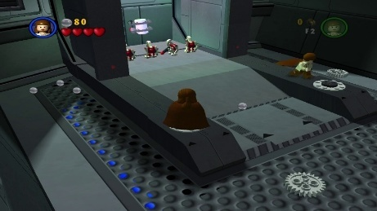Canister 1
  + Address: 0x14
  + Value: 0x01
* 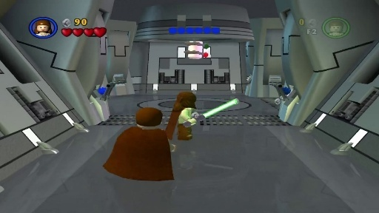Canister 2
  + Address: 0x14
  + Value: 0x08
* 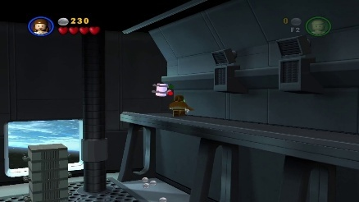Canister 3
  + Address: 0x14
  + Value: 0x10
* 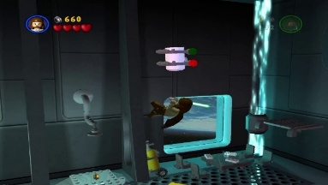Canister 4
  + Address: 0x16
  + 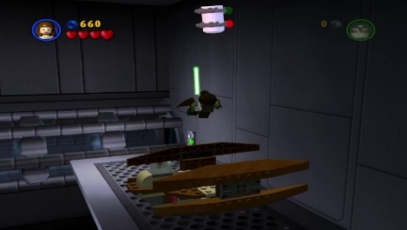Value: 0x01
* Canister 5
  + Address: 0x16
  + Value: 0x02
* 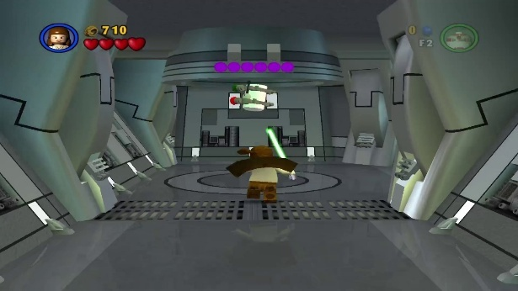Canister 6
  + Address: 0x14
  + Value: 0x04
* 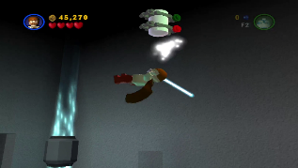Canister 7
  + Address: 0x14
  + Value: 0x02
* 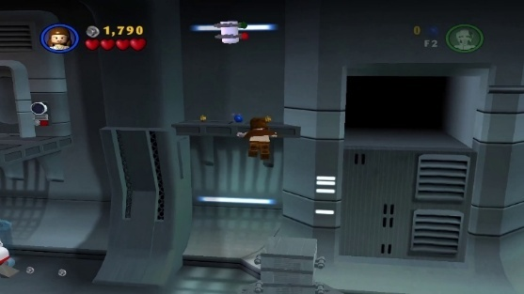Canister 8
  + Address: 0x18
  + Value: 0x02
* 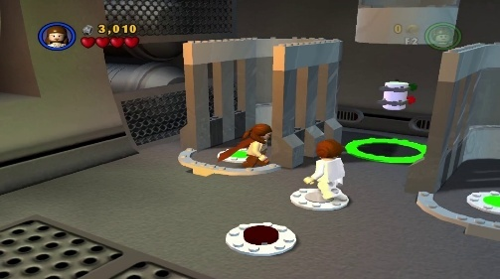Canister 9
  + Address: 0x18
  + Value: 0x04
* 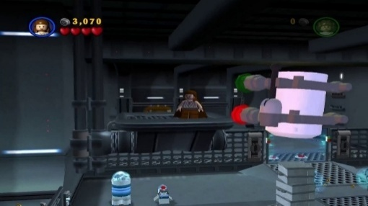Canister 10
  + Address: 0x18
  + Value: 0x01

#### Chapter 2 Invasion of Naboo

* 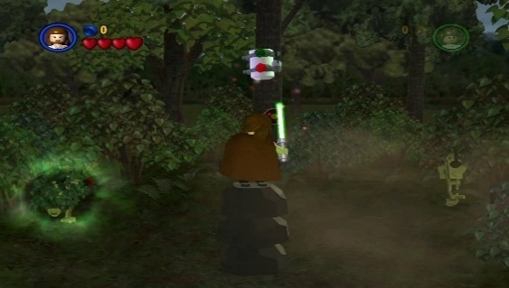Canister 1
  + Address: 0x20
  + Value: 0x08
* 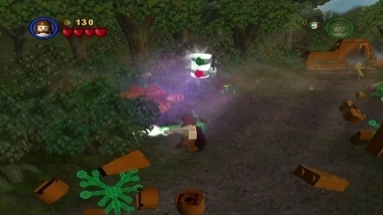Canister 2
  + Address: 0x20
  + Value: 0x10
* 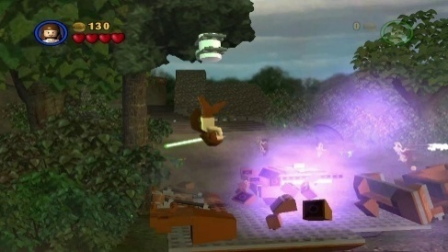Canister 3
  + Address: 0x20
  + Value: 0x02
* 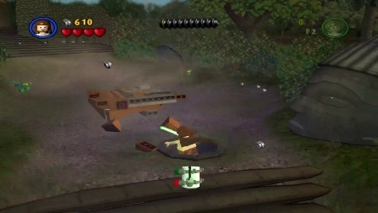Canister 4
  + Address: 0x20
  + Value: 0x04
* 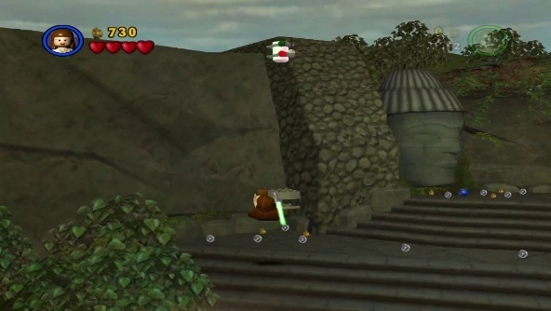Canister 5
  + Address: 0x20
  + Value: 0x01
* 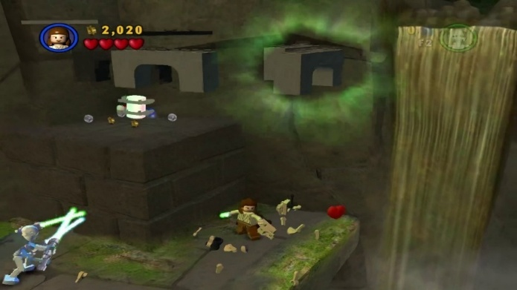Canister 6
  + Address: 0x22
  + Value: 0x01
* 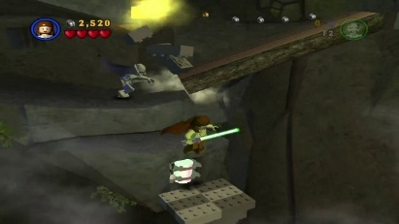Canister 7
  + Address: 0x24
  + Value: 0x02
* 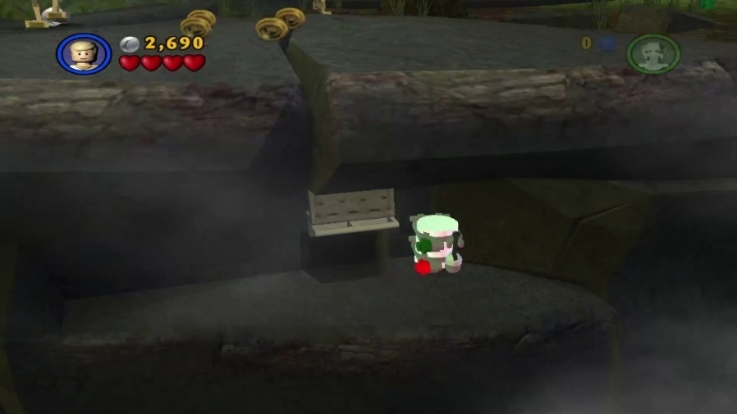Canister 8
  + Address: 0x24
  + Value: 0x01
* 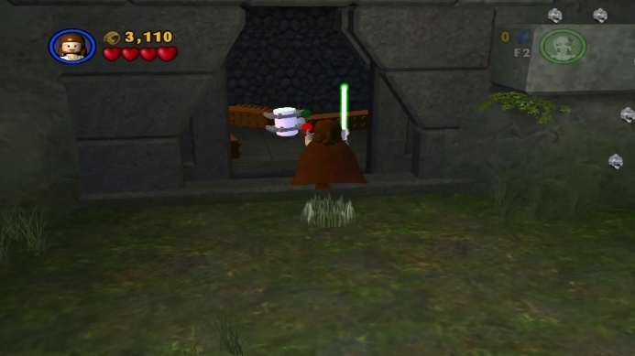Canister 9
  + Address: 0x24
  + Value: 0x04
* 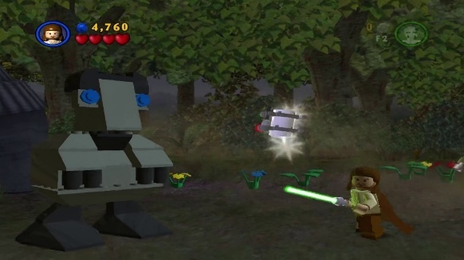Canister 10
  + Address: 0x26
  + Value: 0x01

#### Chapter 3 Escape from Naboo

* 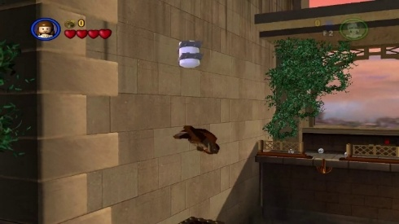Canister 1
  + Address: 0x32
  + Value: 0x02
* 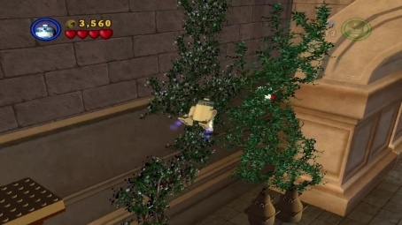Canister 2
  + Address: 0x32
  + Value: 0x01
* 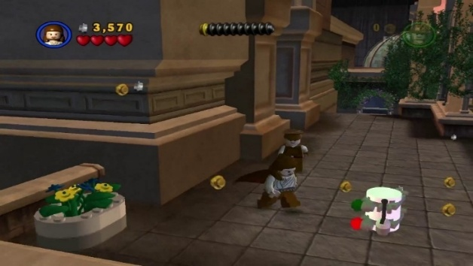Canister 3
  + Address: 0x34
  + Value: 0x02
* 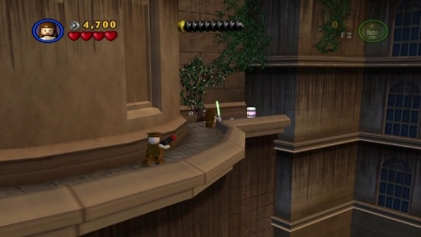Canister 4
  + Address: 0x34
  + Value: 0x04
* 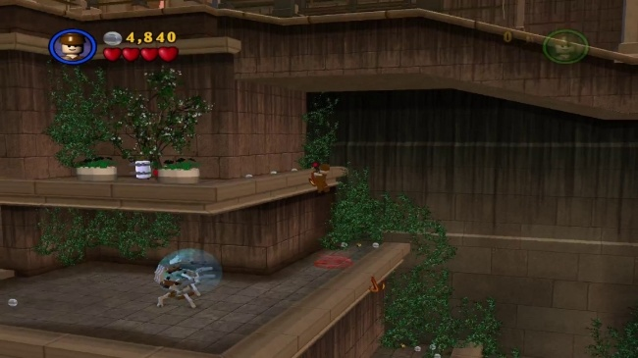Canister 5
  + Address: 0x34
  + Value: 0x01
* 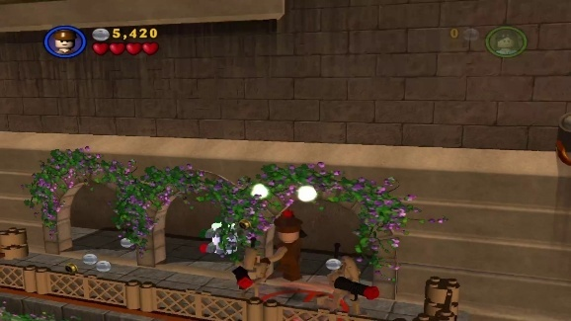Canister 6
  + Address: 0x36
  + Value: 0x02
* 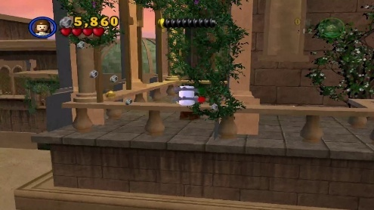Canister 7
  + Address: 0x36
  + Value: 0x01
* 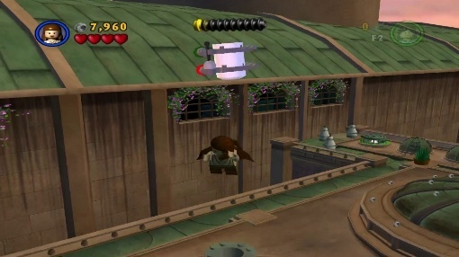Canister 8
  + Address: 0x38
  + Value: 0x04
* 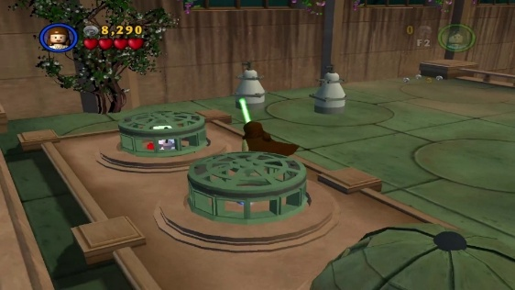Canister 9
  + Address: 0x38
  + Value: 0x02
* 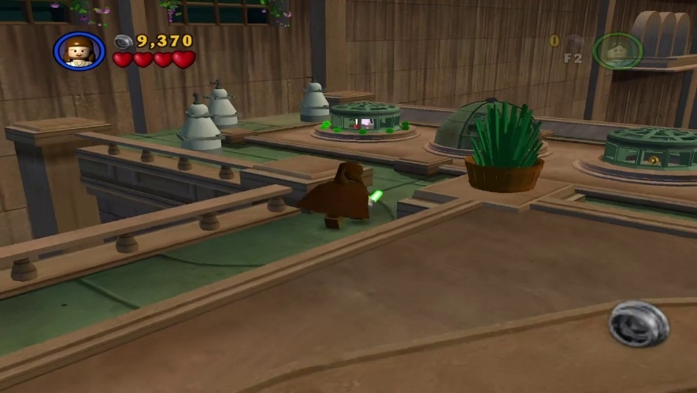Canister 10
  + Address: 0x38
  + Value: 0x01

#### Chapter 4 Mos Espa Podrace

* 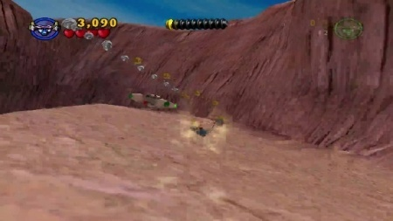Canister 1
  + Address: 0x46
  + Value: 0x04
* 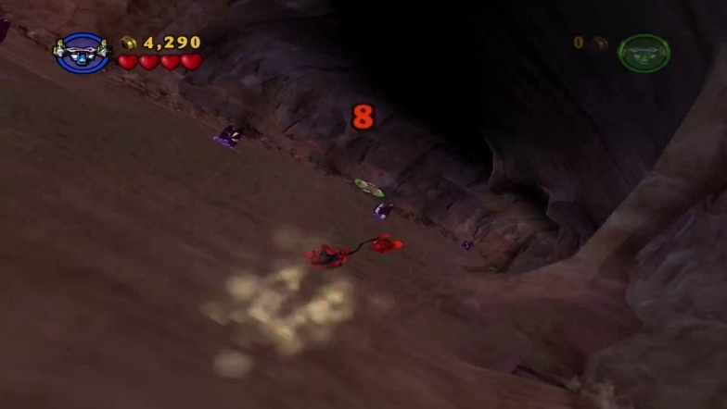Canister 2
  + Address: 0x46
  + Value: 0x08
* 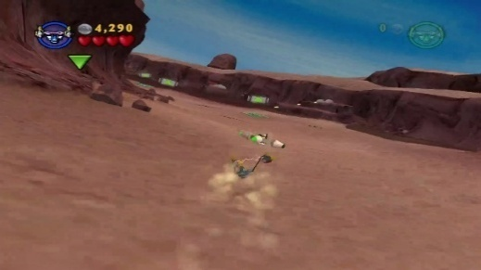Canister 3
  + Address: 0x48
  + Value: 0x01

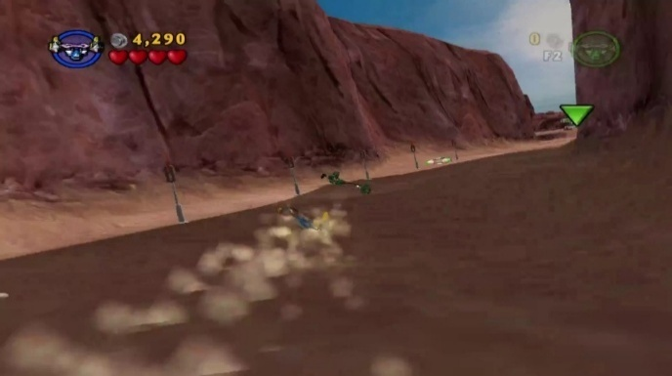

* Canister 4
  + Address: 0x48
  + Value: 0x02
* 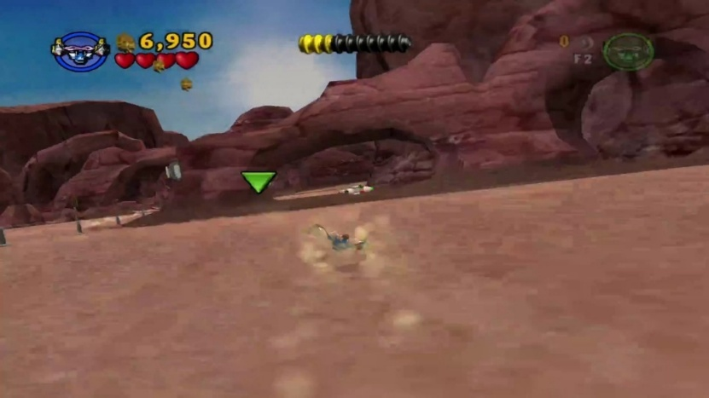Canister 5
  + Address: 0x48
  + Value: 0x04
* 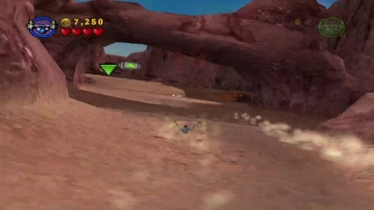Canister 6
  + Address: 0x48
  + Value: 0x08
* 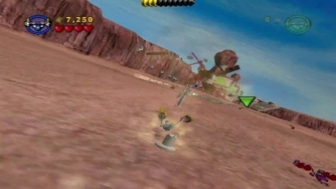Canister 7
  + Address: 0x4A
  + Value: 0x01
* 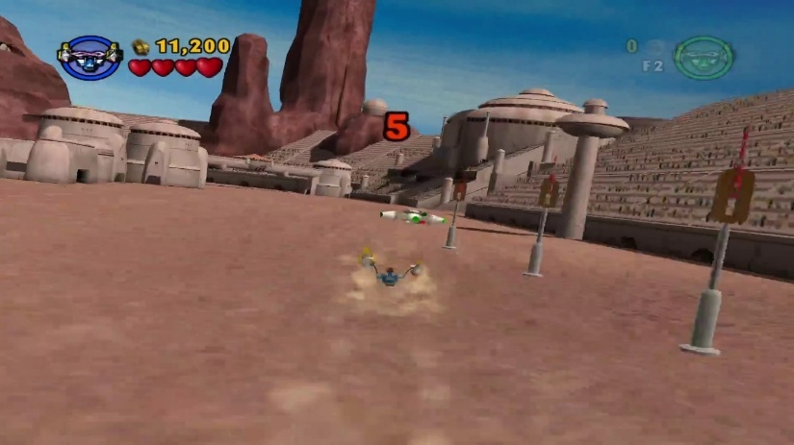Canister 8
  + Address: 0x4A
  + Value: 0x02
* 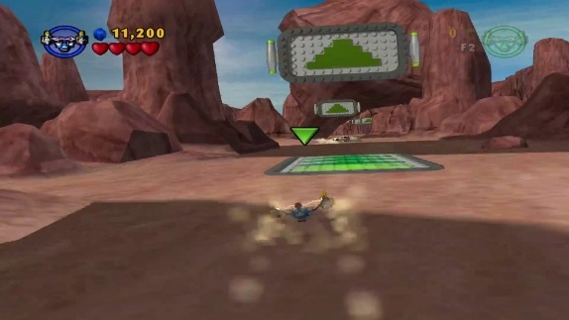Canister 9
  + Address: 0x46
  + Value: 0x01
* 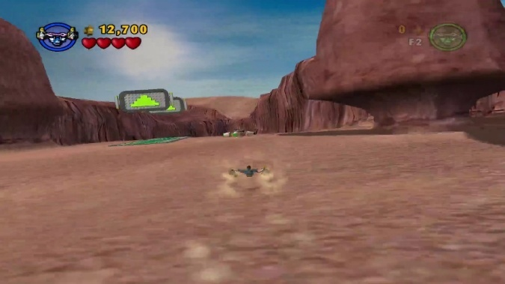Canister 10
  + Address: 0x46
  + Value: 0x02

#### Chapter 5 Retake Theed Palace

* 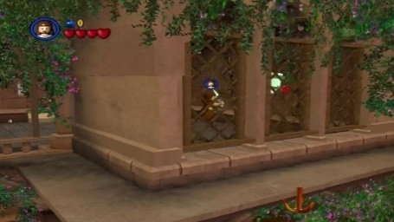Canister 1
  + Address: 0x58
  + Value: 0x02
* 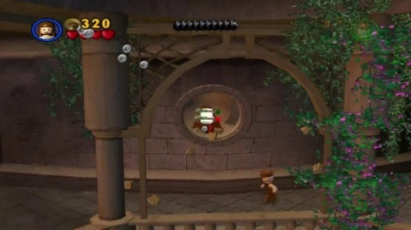Canister 2
  + Address: 0x58
  + Value: 0x01
* 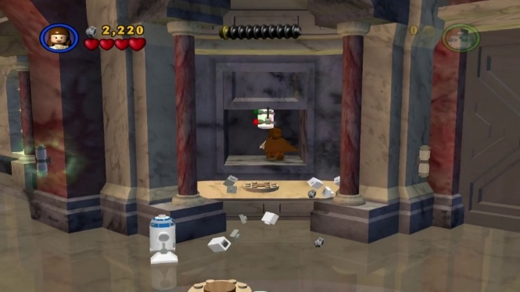Canister 3
  + Address: 0x5A
  + Value: 0x01
* 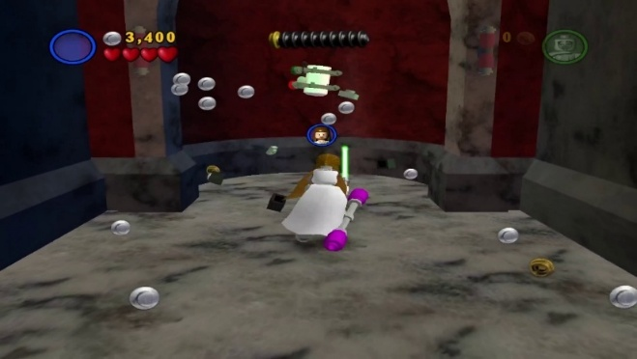Canister 4
  + Address: 0x5A
  + Value: 0x02
* 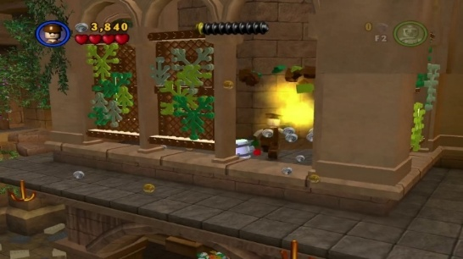Canister 5
  + Address: 0x5C
  + Value: 0x01
* 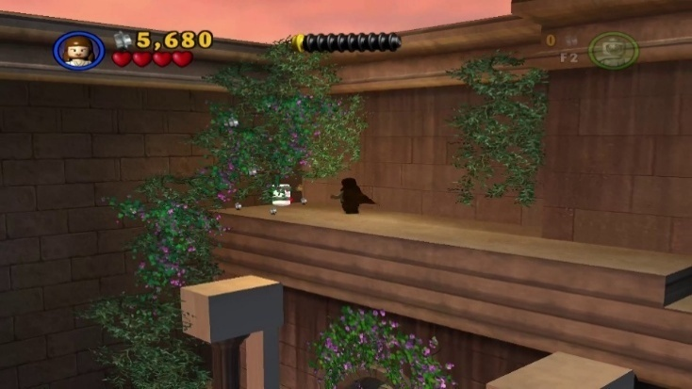Canister 6
  + Address: 0x5C
  + Value: 0x02
* 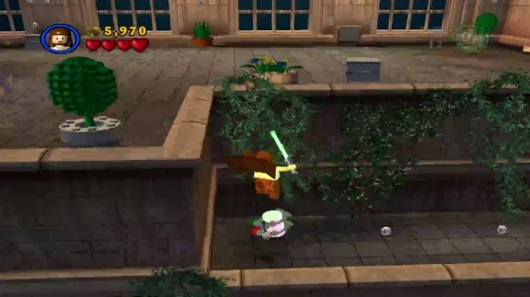Canister 7
  + Address: 0x5E
  + Value: 0x01
* 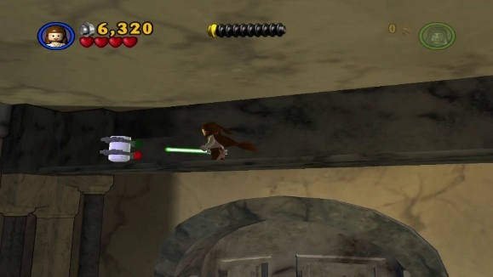Canister 8
  + Address: 0x60
  + Value: 0x01
* 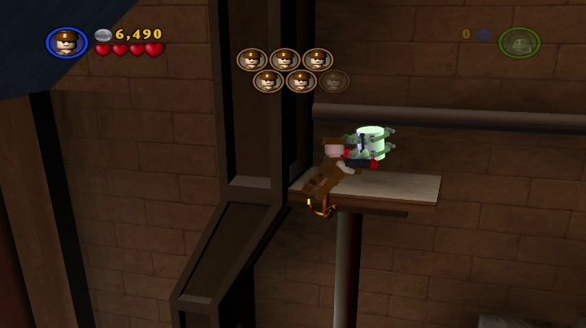Canister 9
  + Address: 0x62
  + Value: 0x02
* 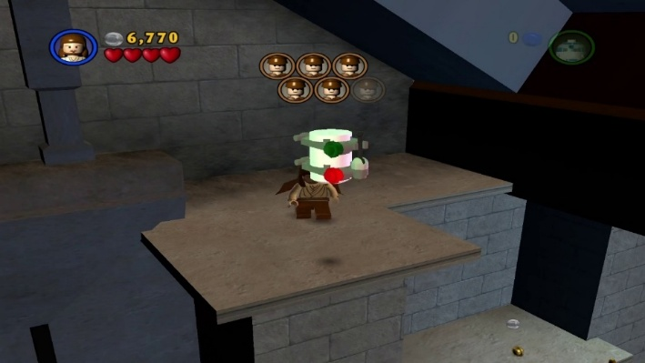Canister 10
  + Address: 0x62
  + Value: 0x01

#### Chapter 6 Darth Maul

* 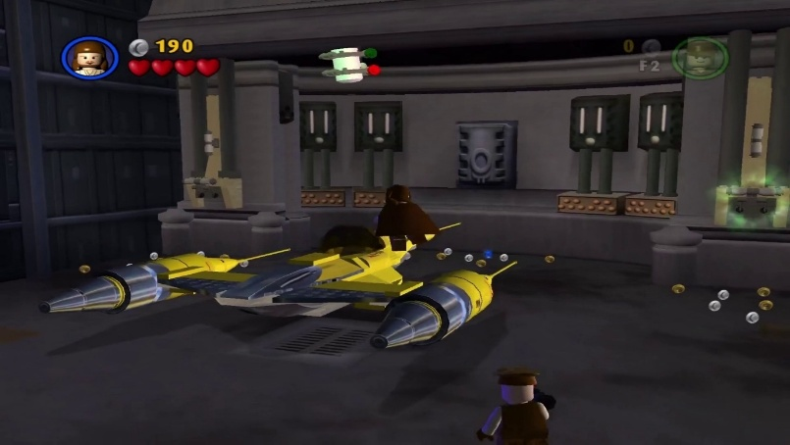Canister 1
  + Address: 0x6A
  + Value: 0x01
* 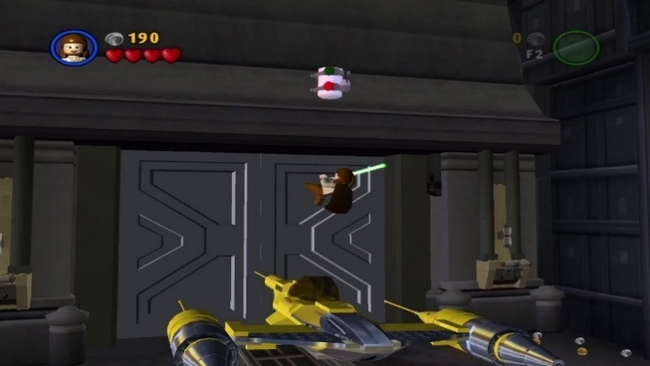Canister 2
  + Address: 0x6A
  + Value: 0x02
* 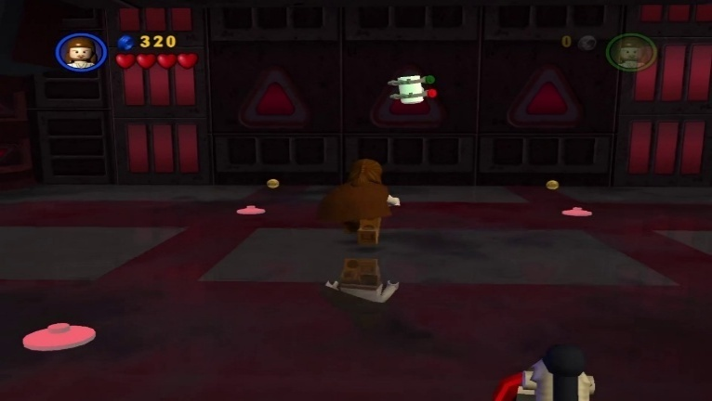Canister 3
  + Address: 0x6C
  + Value: 0x01
* 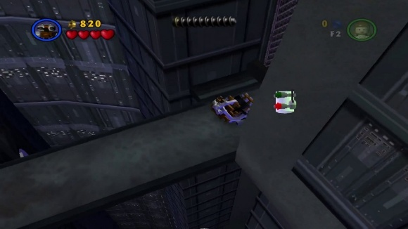Canister 4
  + Address: 0x6C
  + Value: 0x04
* 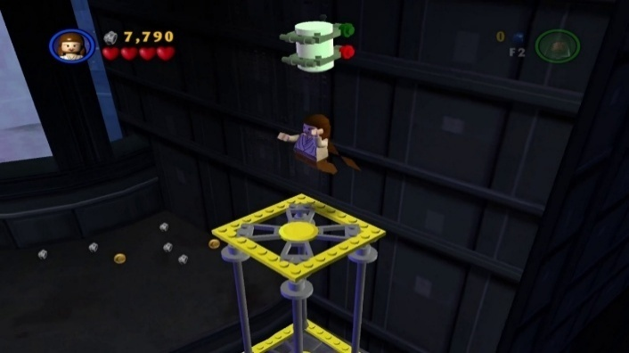Canister 5
  + Address: 0x6C
  + Value: 0x02
* 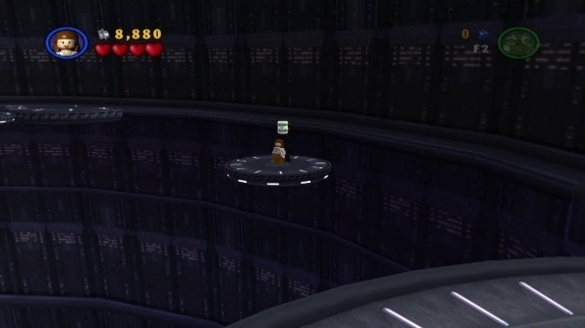Canister 6
  + Address: 0x6E
  + Value: 0x01
* 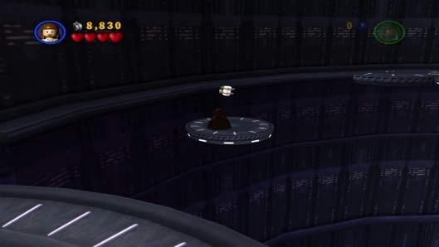Canister 7
  + Address: 0x6E
  + Value: 0x02
* 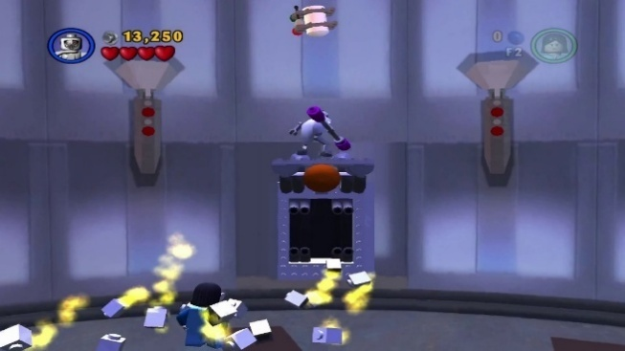Canister 8
  + Address: 0x72
  + Value: 0x01
* 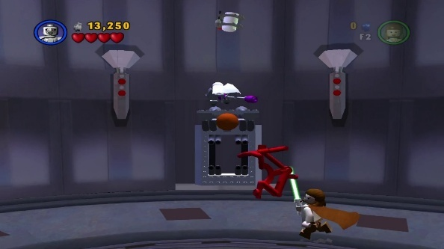Canister 9
  + Address: 0x72
  + Value: 0x04
* 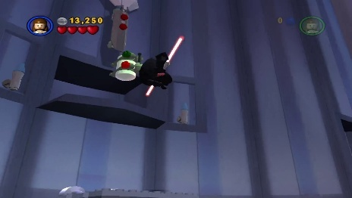Canister 10
  + Address: 0x72
  + Value: 0x02

### Episode II Attack Of The Clones

#### Chapter 1 Discovery On Kamino

* 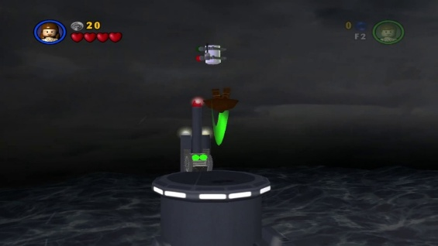Canister 1
  + Address: 0x7C
  + Value: 0x01
* 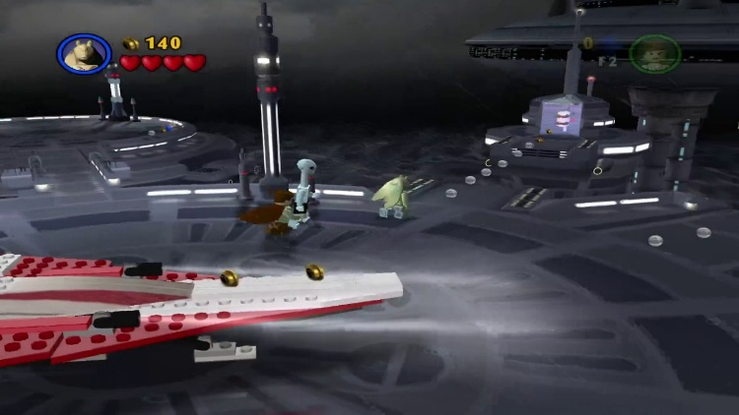Canister 2
  + Address: 0x7C
  + Value: 0x02
* 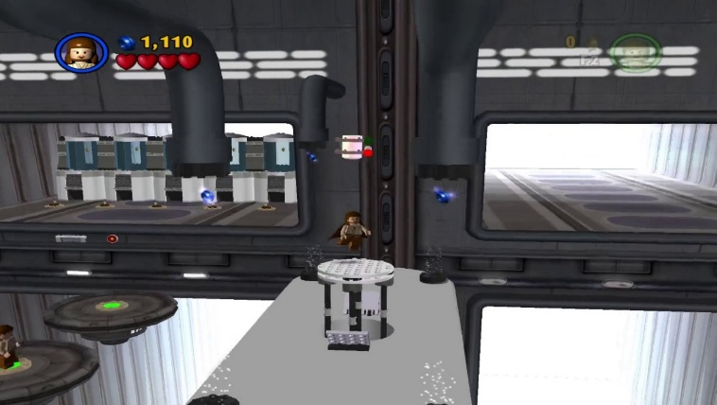Canister 3
  + Address: 0x80
  + Value: 0x02
* 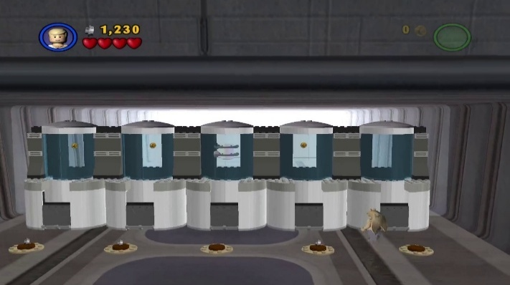Canister 4
  + Address: 0x80
  + Value: 0x01
* 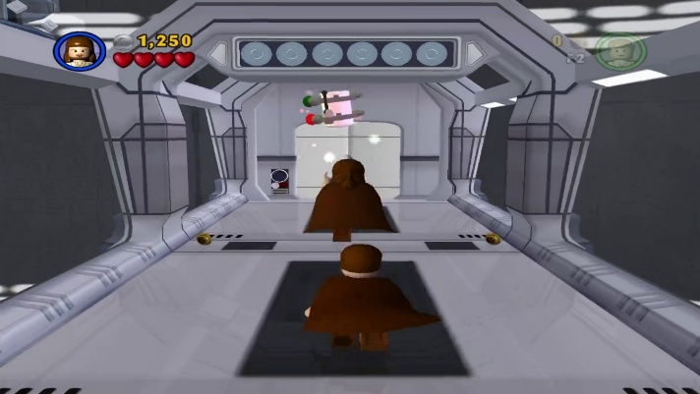Canister 5
  + Address: 0x80
  + Value: 0x04
* 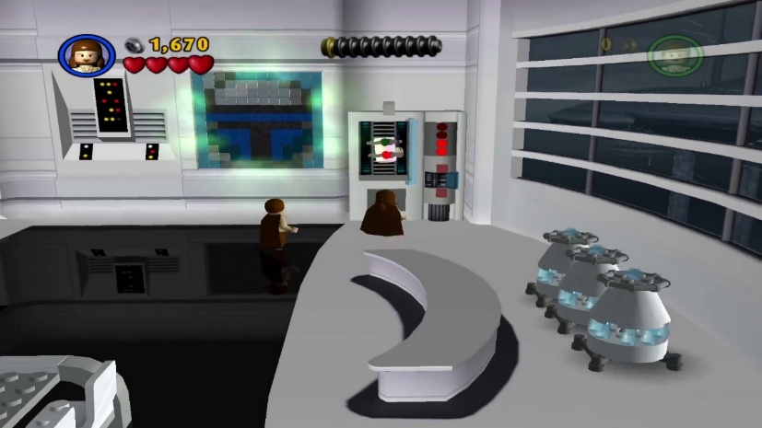Canister 6
  + Address: 0x7E
  + Value: 0x04
* 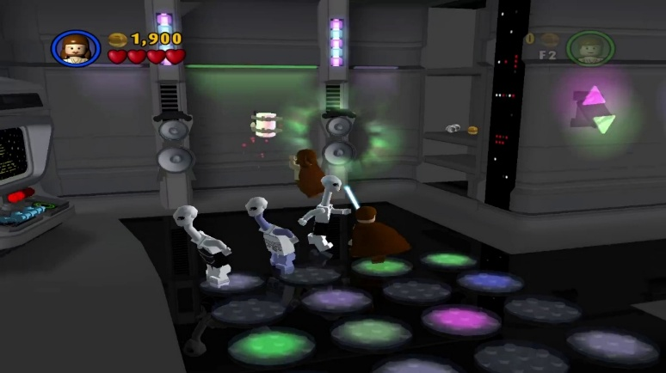Canister 7
  + Address: 0x7E
  + Value: 0x02
* 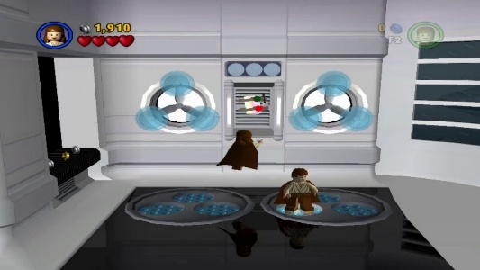Canister 8
  + Address: 0x7E
  + Value: 0x01
* 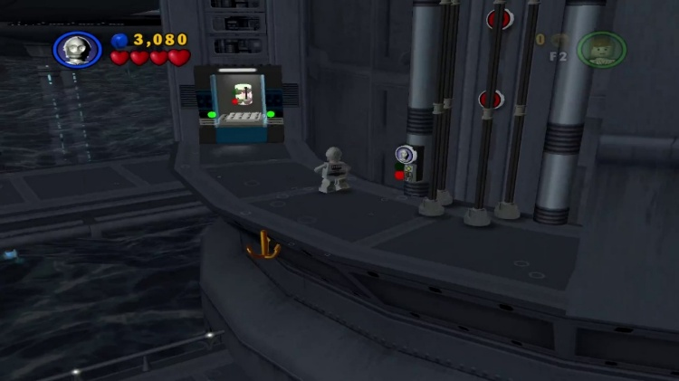Canister 9
  + Address: 0x84
  + Value: 0x01
* 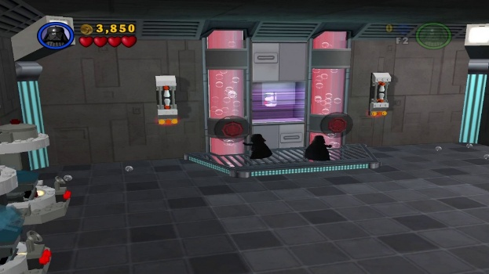Canister 10
  + Address: 0x82
  + Value: 0x01

#### Chapter 2 Droid Factory

* 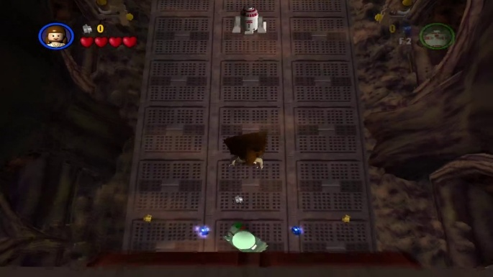Canister 1
  + Address: 0x92
  + Value: 0x01
* 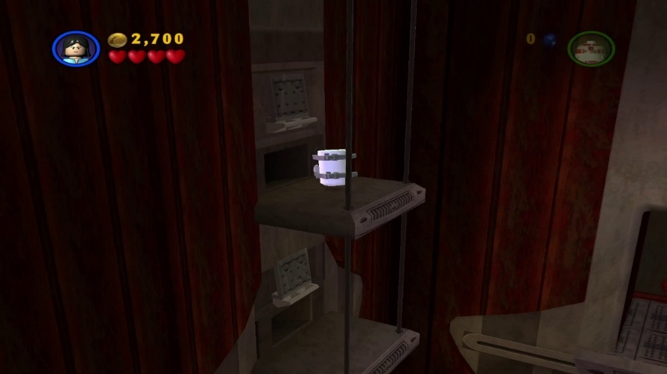Canister 2
  + Address: 0x94
  + Value: 0x01
* 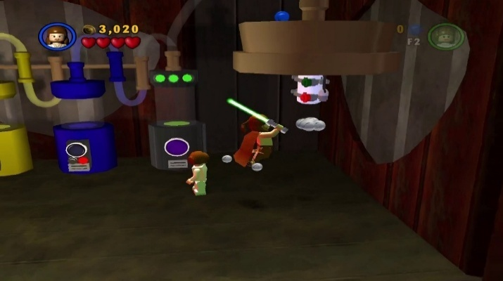Canister 3
  + Address: 0x94
  + Value: 0x02
* 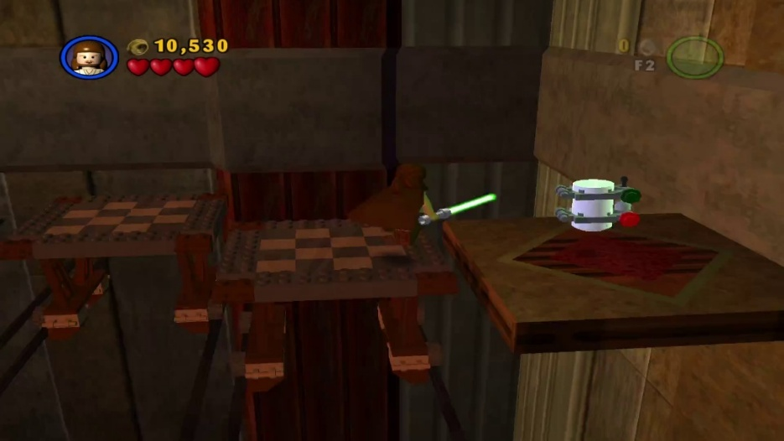Canister 4
  + Address: 0x96
  + Value: 0x01
* 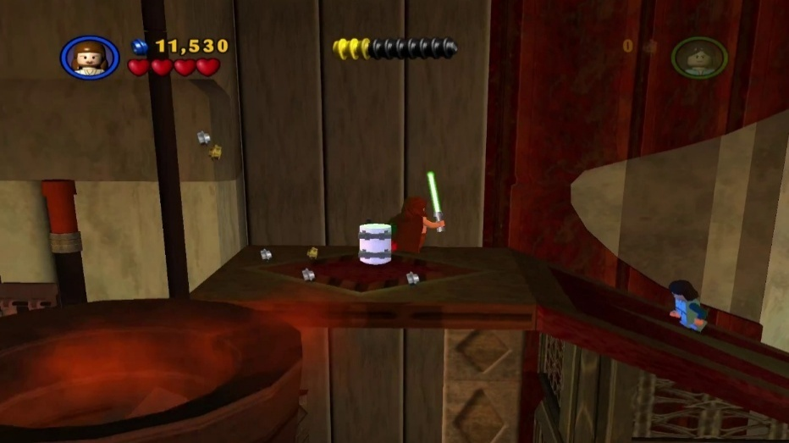Canister 5
  + Address: 0x96
  + Value: 0x02
* 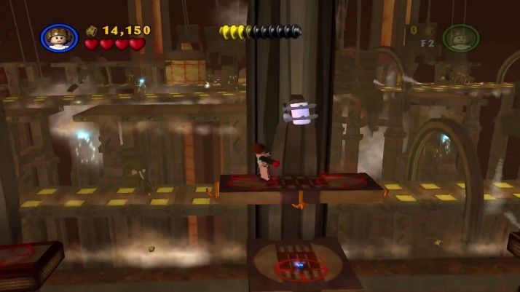Canister 6
  + Address: 0x098
  + Value: 0x01
* 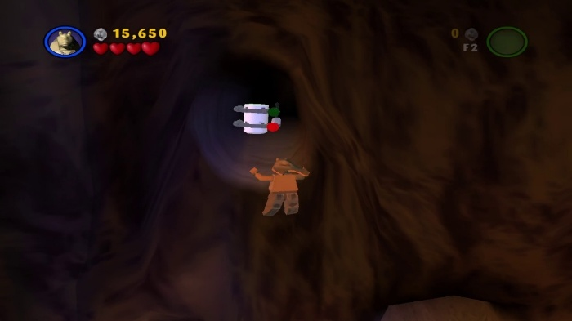Canister 7
  + Address: 0x9A
  + Value: 0x02
* 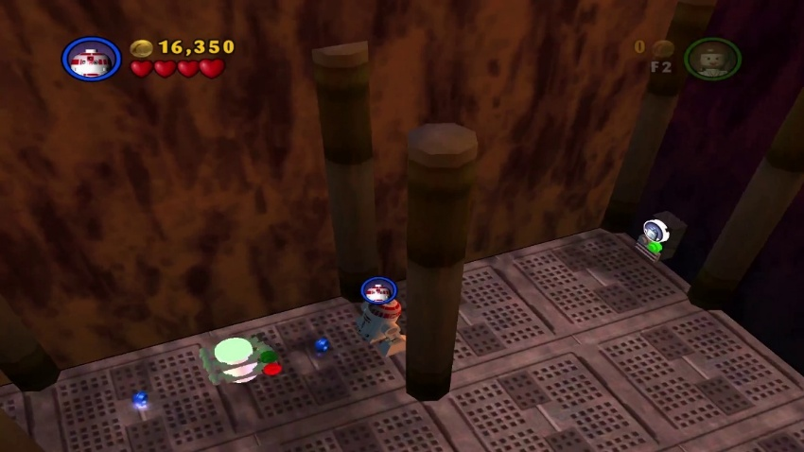Canister 8
  + Address: 0x9A
  + Value: 0x04
* 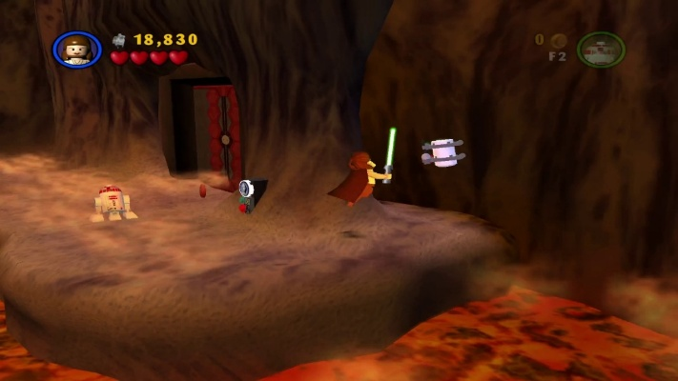Canister 9
  + Address: 0x9A
  + Value: 0x01
* 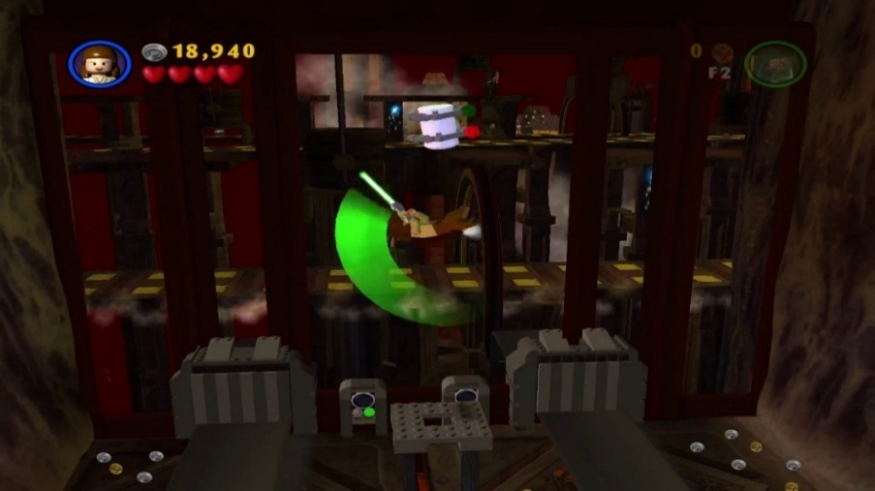Canister 10
  + Address: 0x9C
  + Value: 0x01

#### Chapter 3 Jedi Battle

* 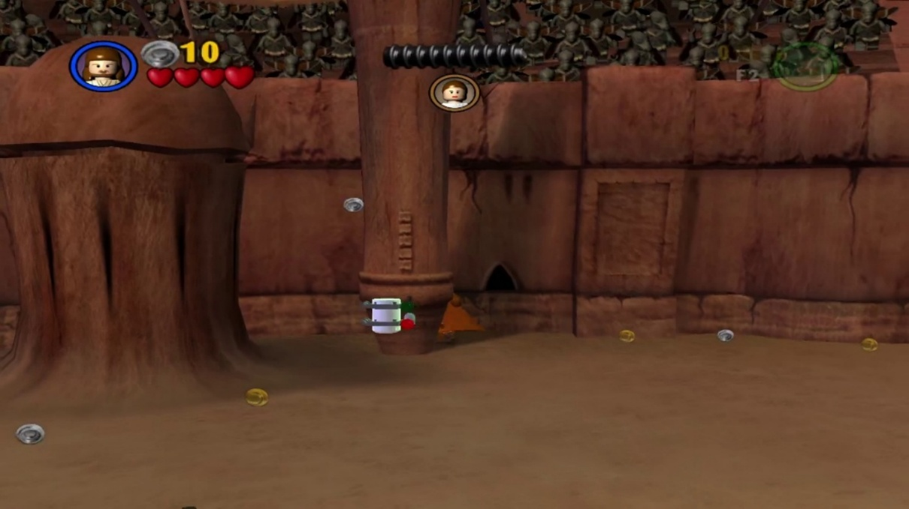Canister 1
  + Address: 0xA2
  + Value: 0x10
* 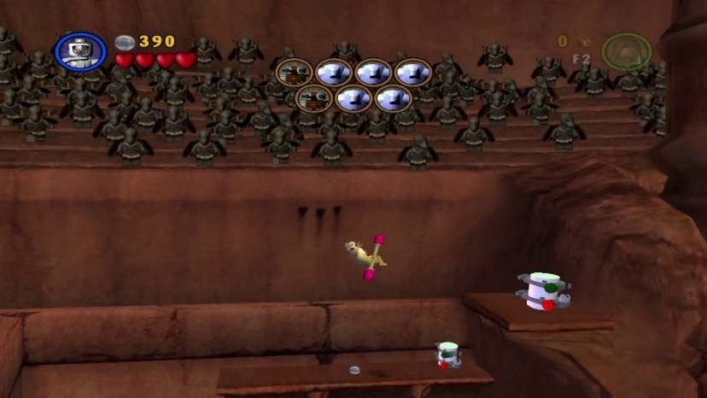Canister 2
  + Address: 0xA2
  + Value: 0x01
* 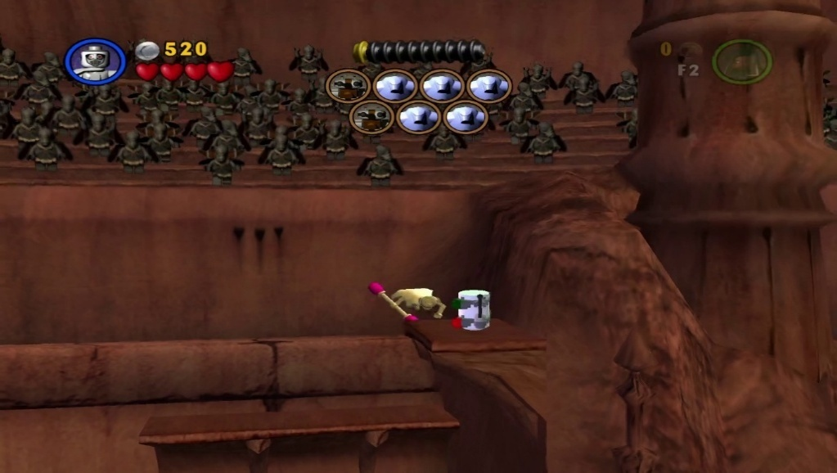Canister 3
  + Address: 0xA2
  + Value: 0x04
* 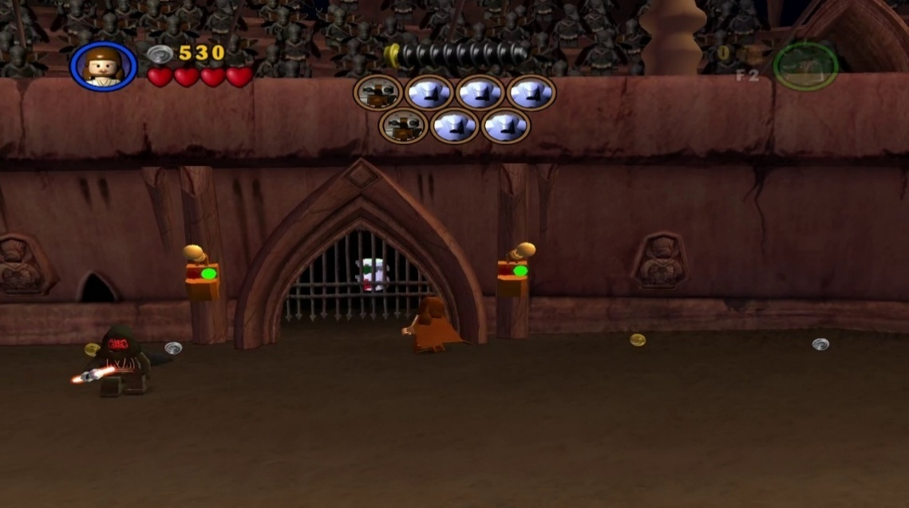Canister 4
  + Address: 0xA2
  + Value: 0x80
* 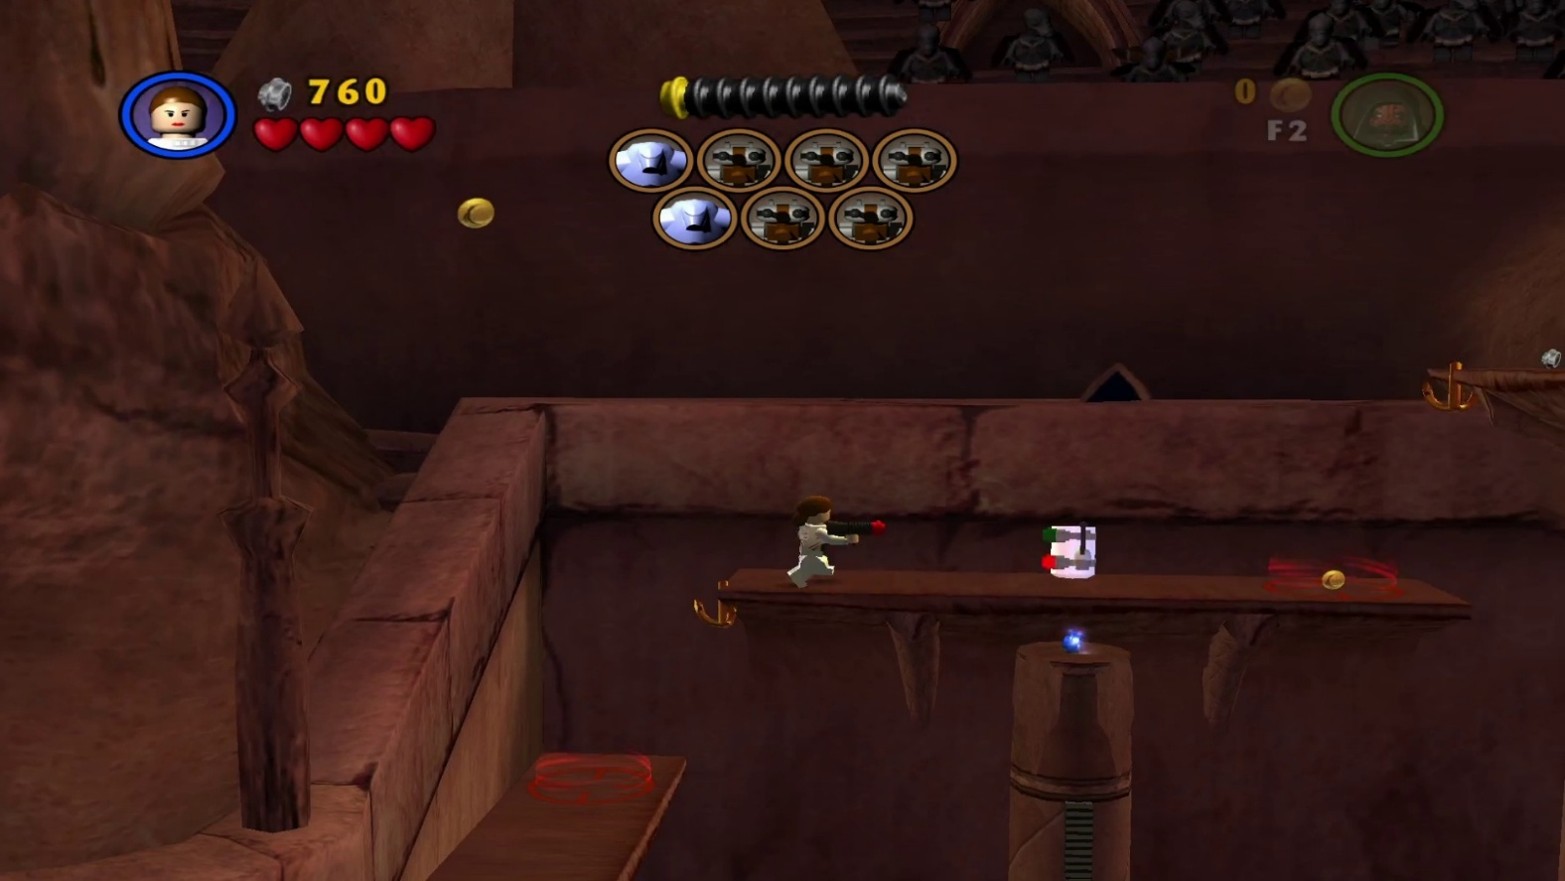Canister 5
  + Address: 0xA2
  + Value: 0x08
* 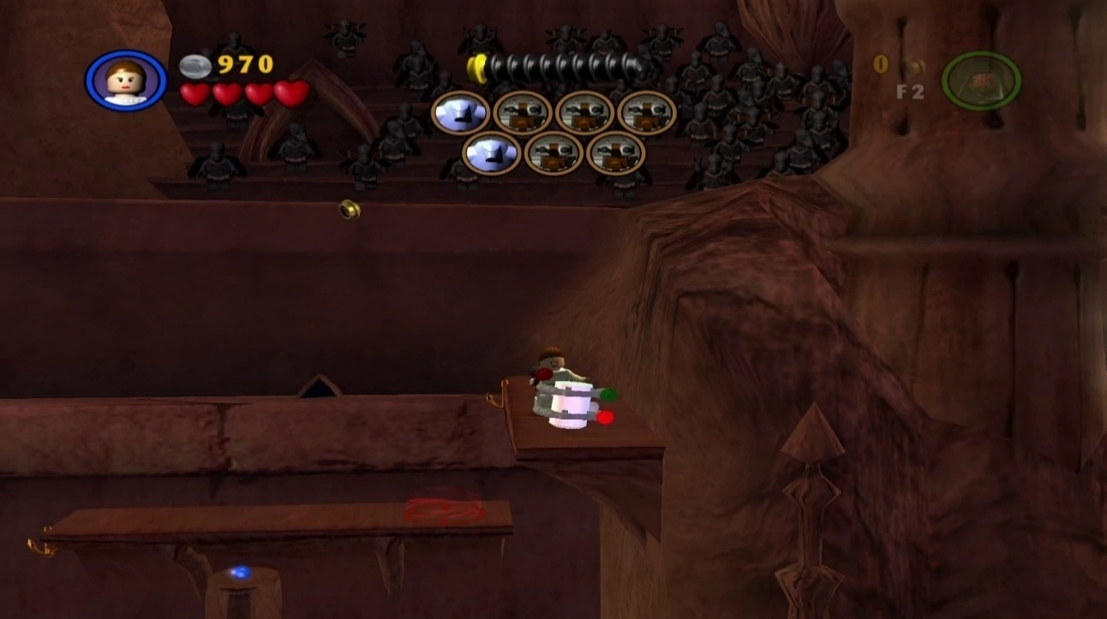Canister 6
  + Address: 0xA2
  + Value: 0x20
* 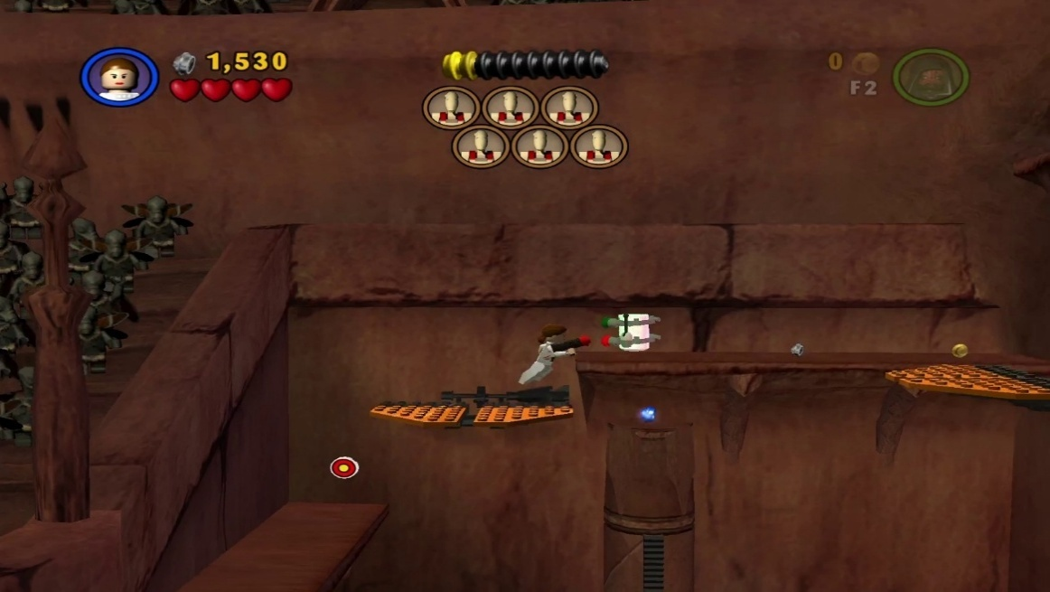Canister 7
  + Address: 0xA3
  + Value: 0x02
* 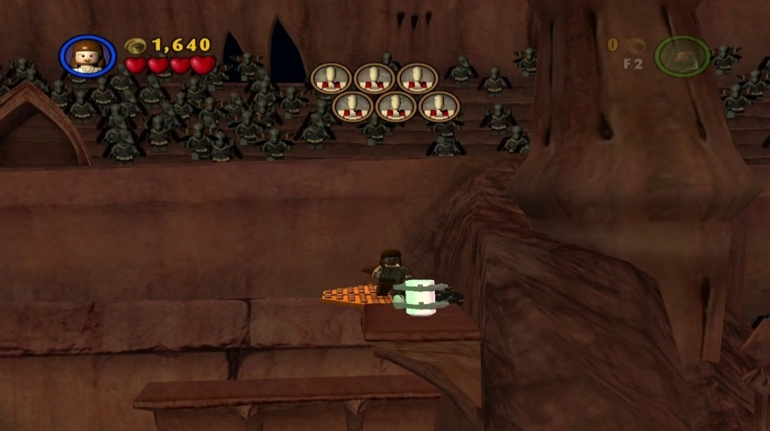Canister 8
  + Address: 0xA3
  + Value: 0x01
* 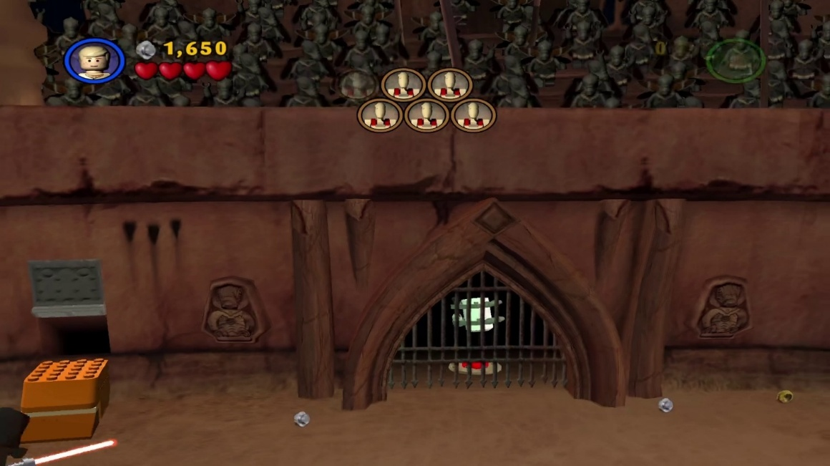Canister 9
  + Address: 0xA2
  + Value: 0x40
* 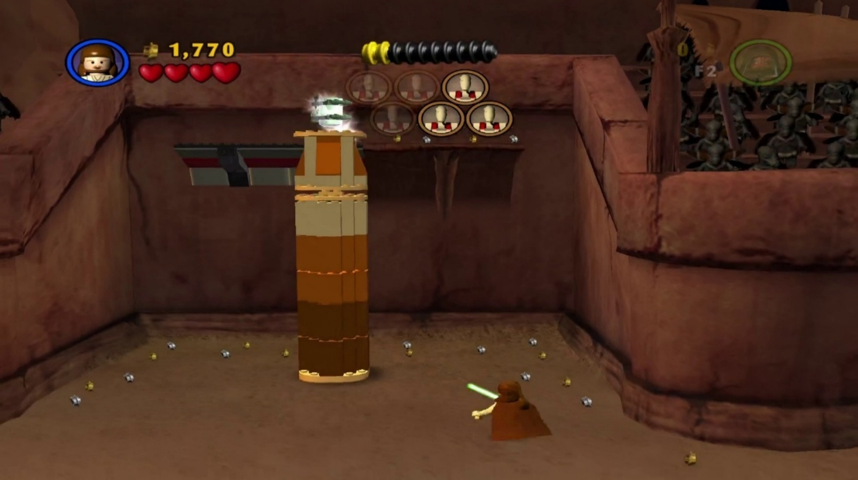Canister 10
  + Address: 0xA2
  + Value: 0x02

#### Chapter 4 Gunship Cavalry

* 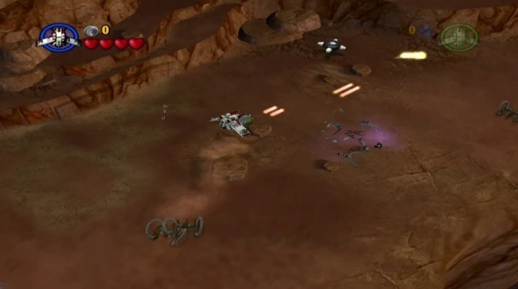Canister 1
  + Address: 0xA8
  + Value: 0x1
* 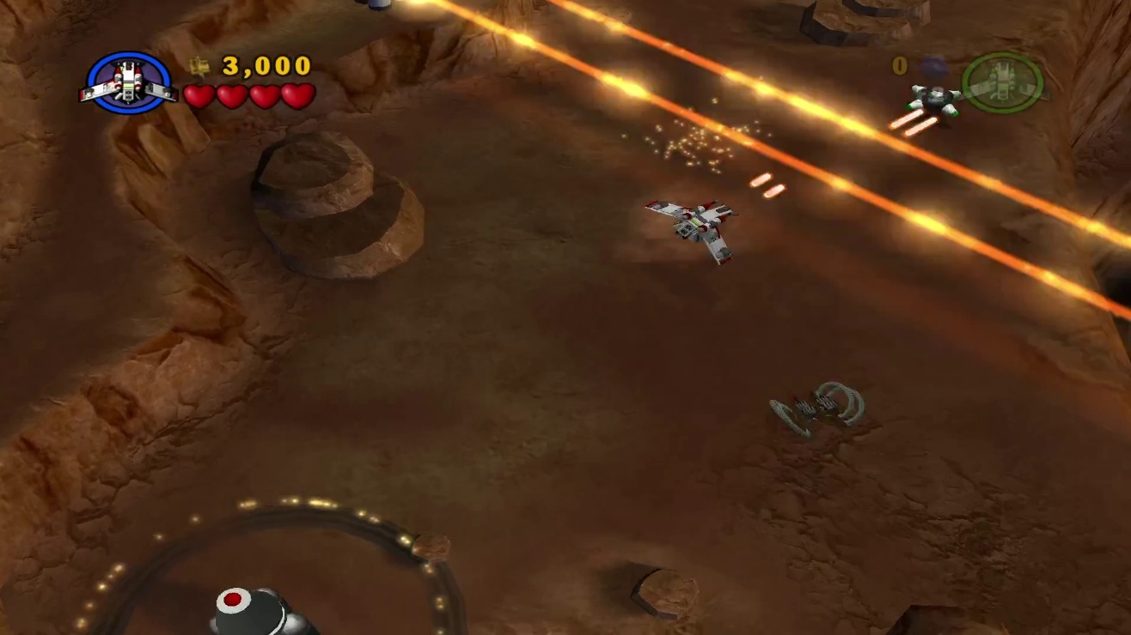Canister 2
  + Address: 0xA8
  + Value: 0x02
* 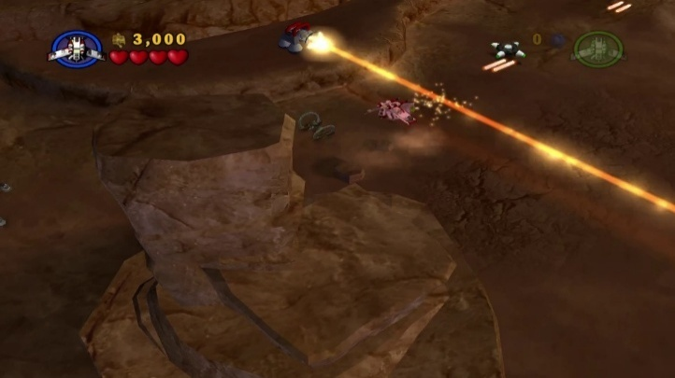Canister 3
  + Address: 0xA8
  + Value: 0x04
* 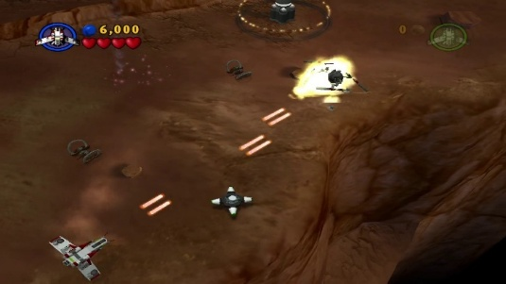Canister 4
  + Address: 0xA8
  + Value: 0x08
* 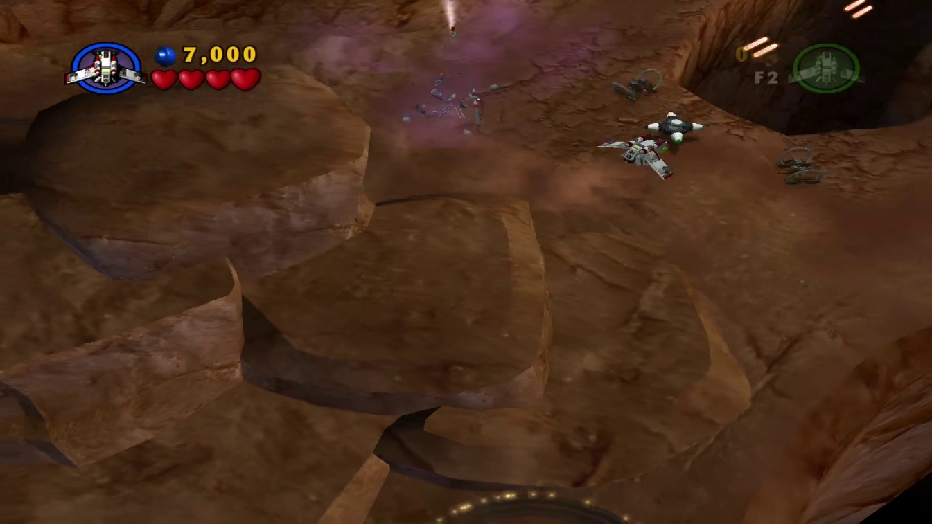Canister 5
  + Address: 0xA8
  + Value: 0x10
* 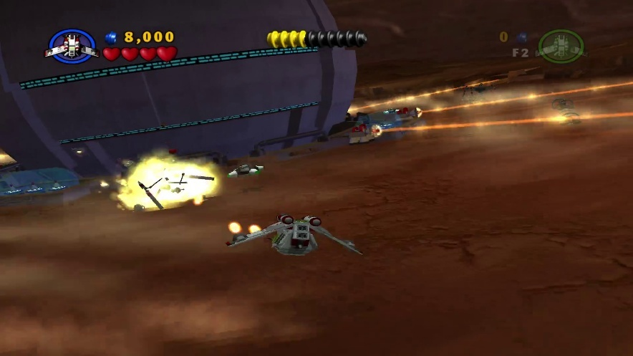Canister 6
  + Address: 0xAA
  + Value: 0x02
* 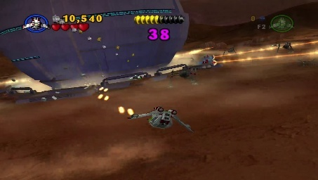Canister 7
  + Address: 0xAA
  + Value: 0x01
* 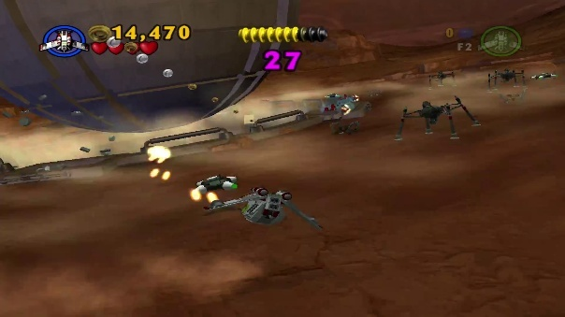Canister 8
  + Address: 0xAA
  + Value: 0x04
* 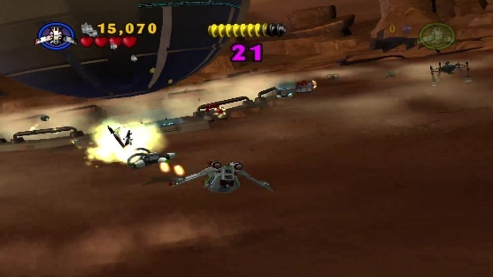Canister 9
  + Address: 0xAA
  + Value:0x08
* 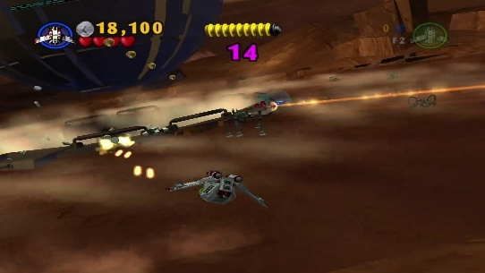Canister 10
  + Address: 0xAA
  + Value: 0x10

#### Chapter 6 Count Dooku

* 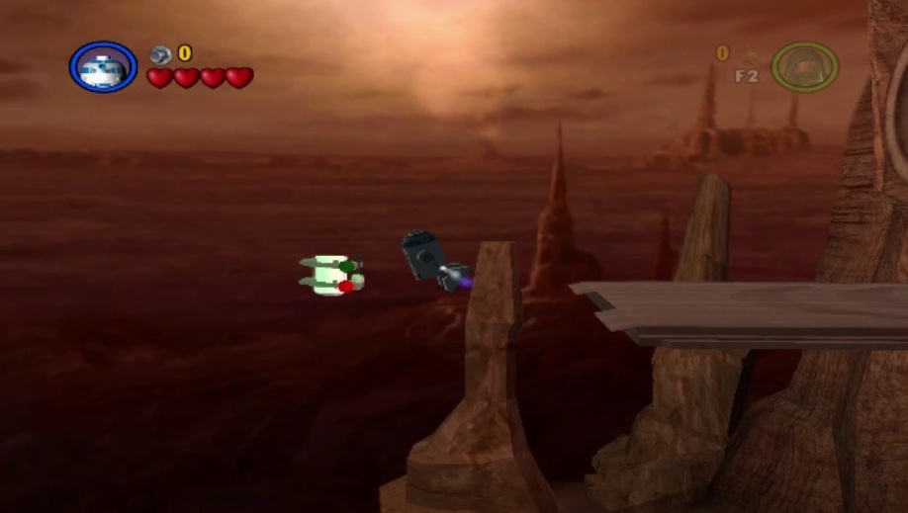Canister 1
  + Address: 0xB0
  + Value: 0x01
* 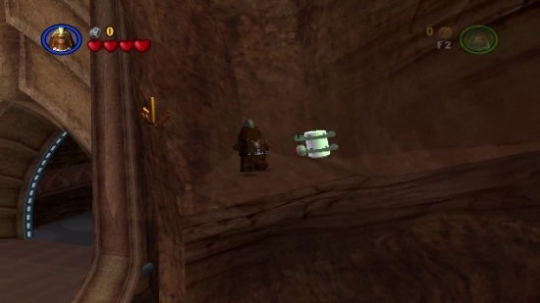Canister 2
  + Address: 0xB0
  + Value: 0x08
* 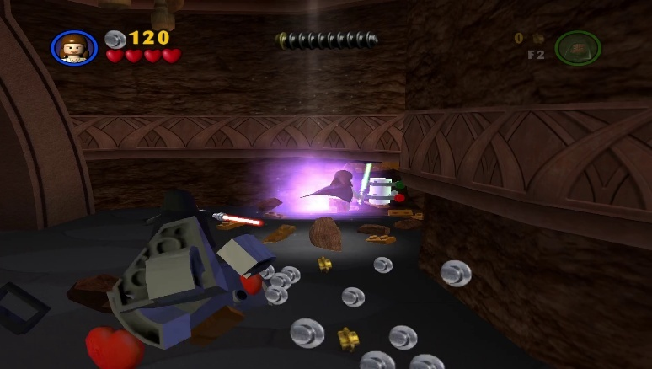Canister 3
  + Address: 0xB0
  + Value: 0x04
* 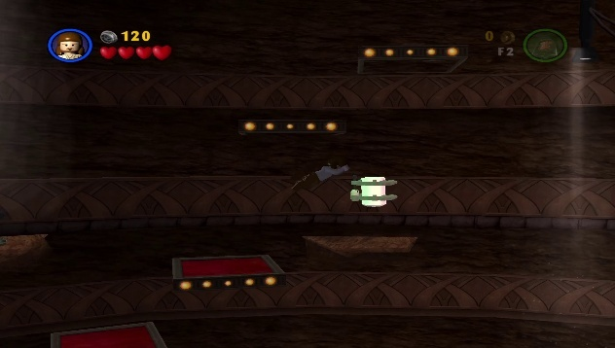Canister 4
  + Address: 0xB0
  + Value: 0x10
* 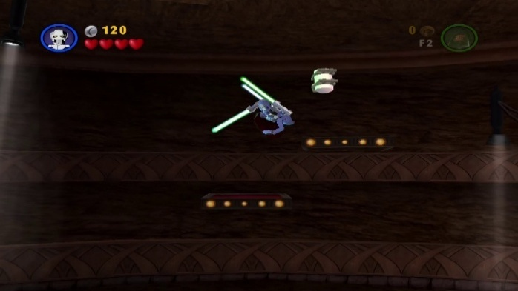Canister 5
  + Address: 0xB0
  + Value: 0x20
* 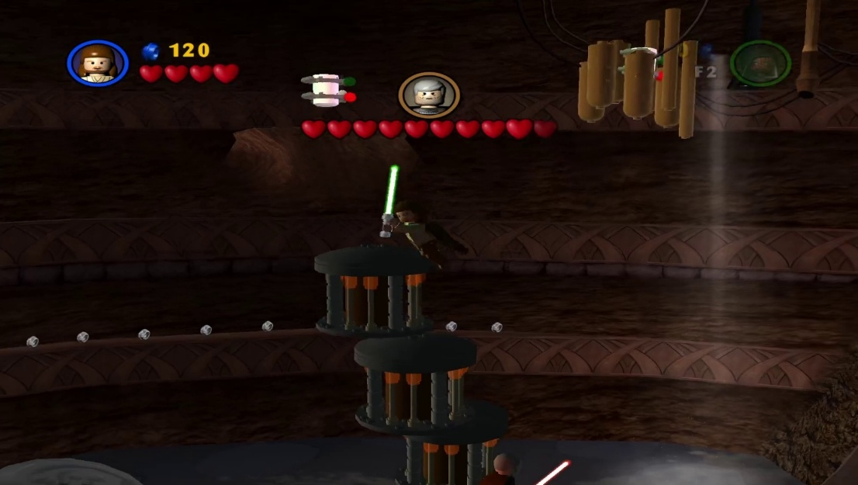Canister 6
  + Address: 0xB0
  + Value: 0x02
* 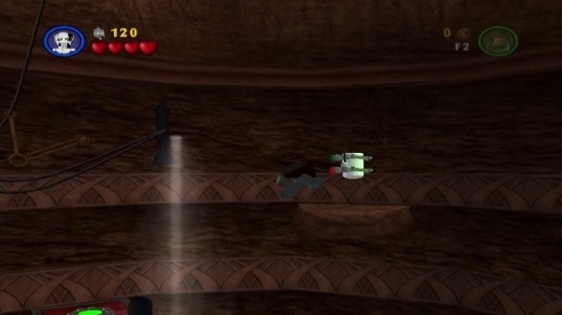Canister 7
  + Address: 0xB2
  + Value: 0x04
* 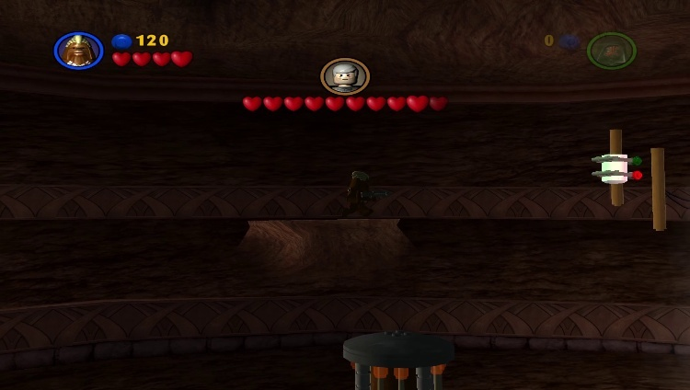Canister 8
  + Address: 0xB2
  + Value: 0x08
* 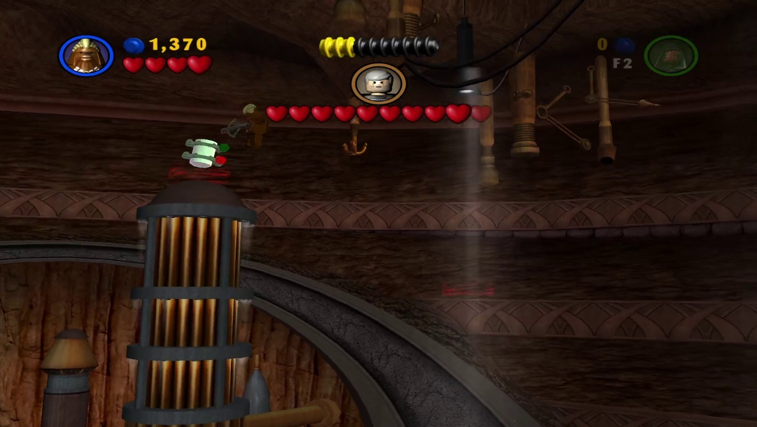Canister 9
  + Address: 0xB2
  + Value: 0x01
* 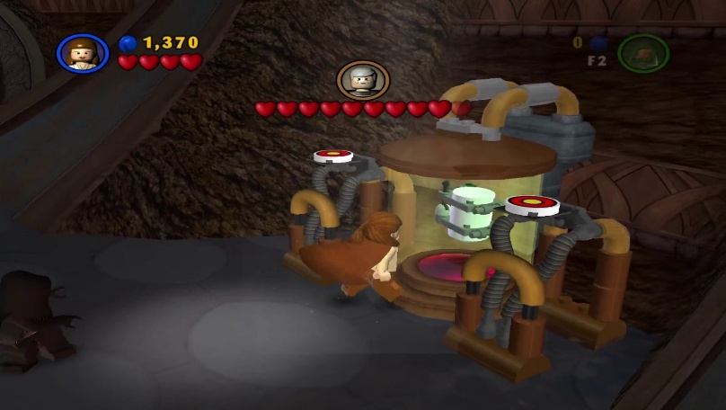Canister 10
  + Address: 0xB2
  + Value: 0x02

### Episode III Revenge Of The Sith

#### Chapter 1 Battle Over Coruscant

* 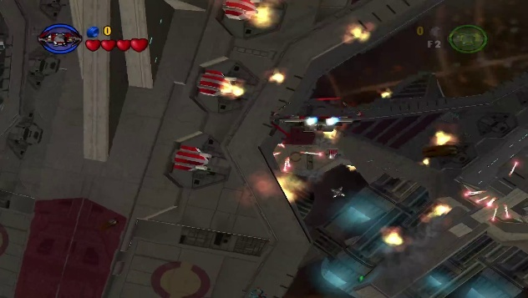Canister 1
  + Address: 0xBC
  + Value: 0x01
* 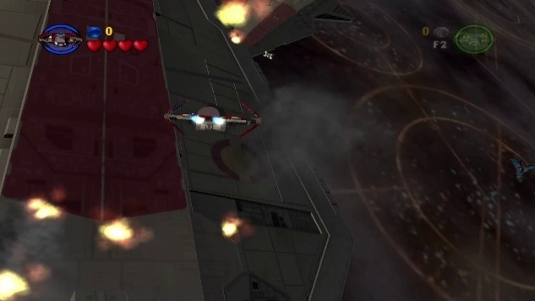Canister 2
  + Address: 0xBC
  + Value: 0x02
* 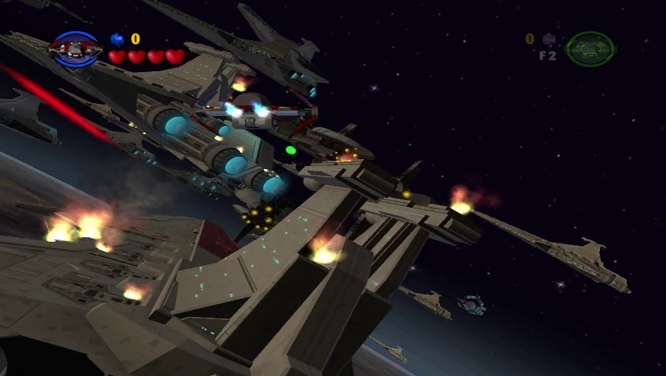Canister 3
  + Address: 0xBC
  + Value: 0x04
* 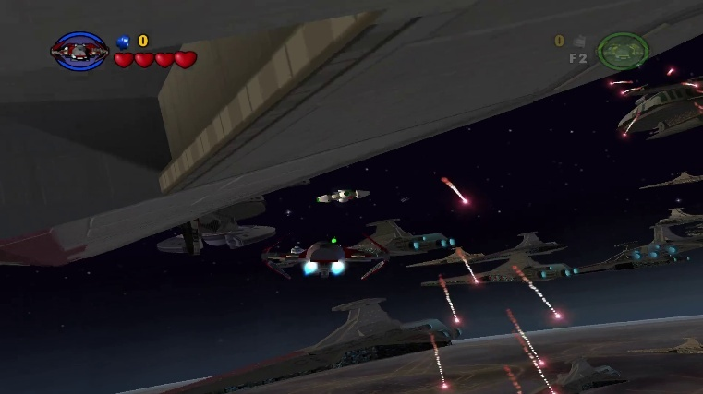Canister 4
  + Address: 0xBC
  + Value: 0x08
* 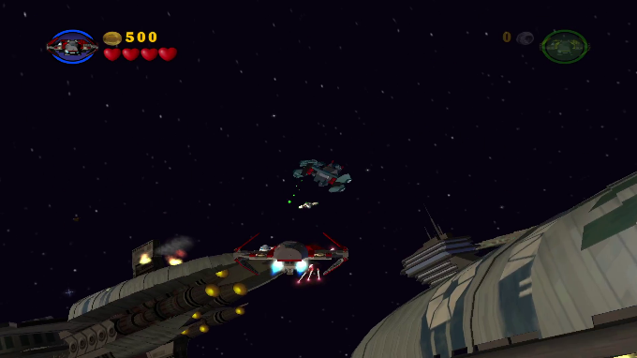Canister 5
  + Address: 0xBC
  + Value: 0x10
* 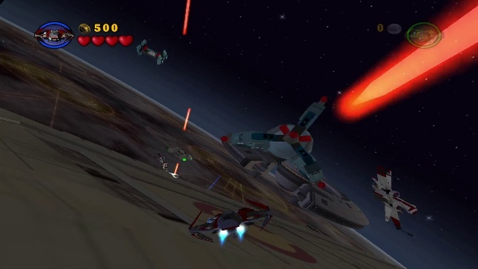Canister 6
  + Address: 0xBC
  + 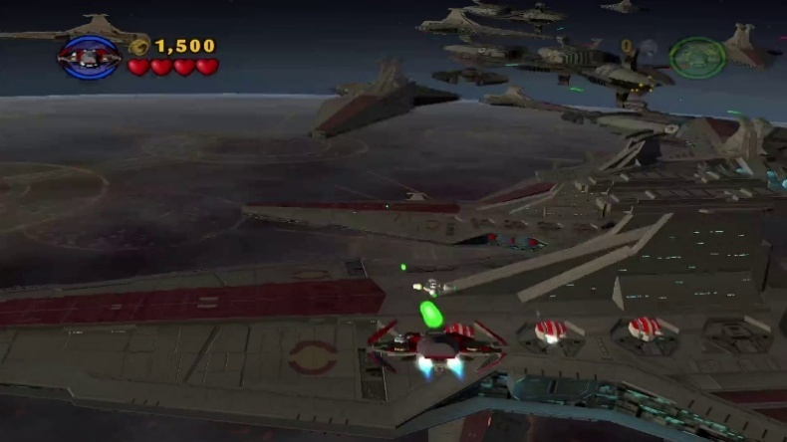Value: 0x20
* Canister 7
  + Address: 0xBC
  + Value: 0x40
* 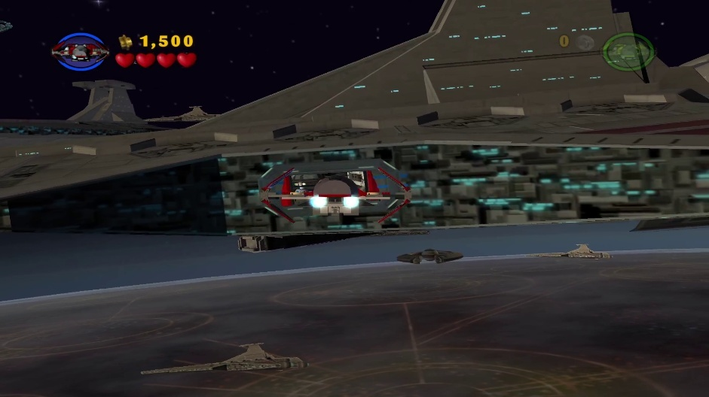Canister 8
  + Address: 0xBC
  + Value: 0x80
* 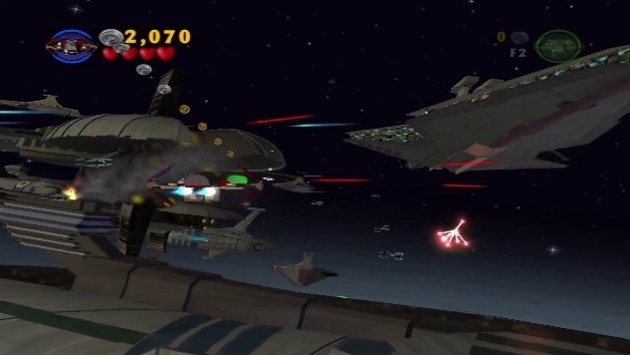Canister 9
  + Address: 0xBD
  + Value: 0x01
* 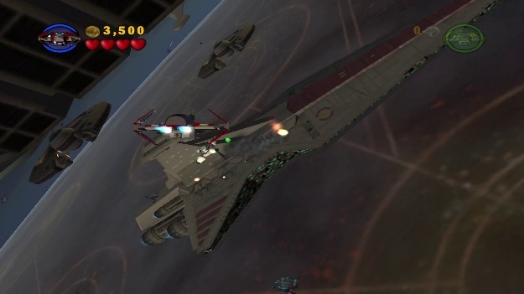Canister 10
  + Address: 0xBD
  + Value: 0x02

#### Chapter 2 Chancellor In Peril

* 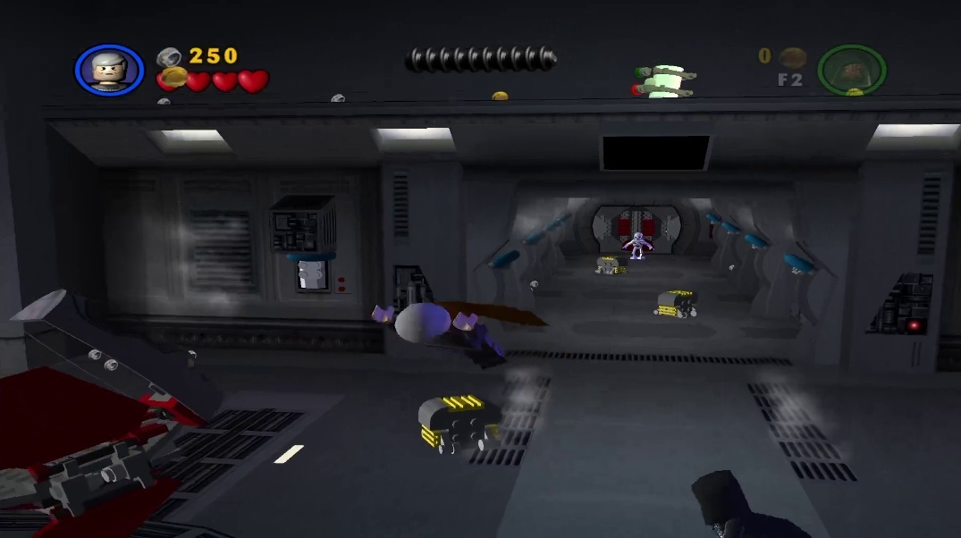Canister 1
  + Address: 0xC0
  + Value: 0x01
* 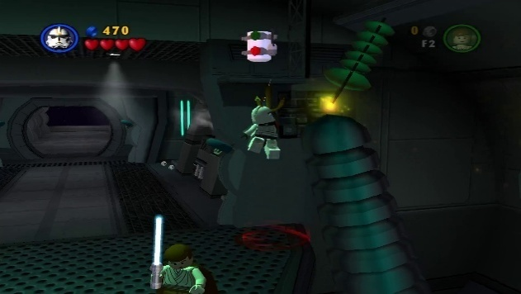Canister 2
  + Address: 0xCC
  + Value: 0x01
* 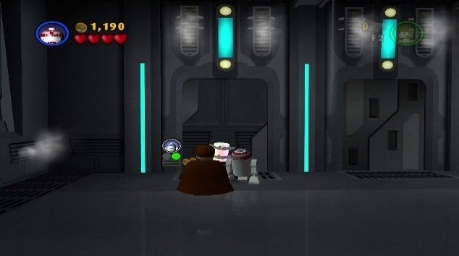Canister 3
  + Address: 0xC2
  + Value: 0x01
* 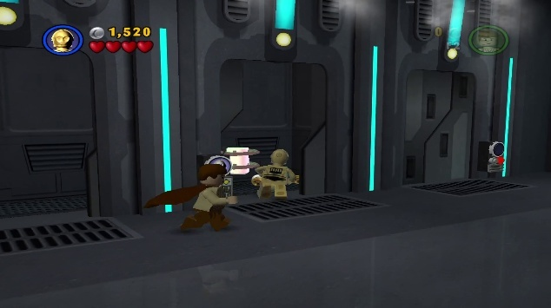Canister 4
  + Address: 0xC2
  + Value: 0x02
* 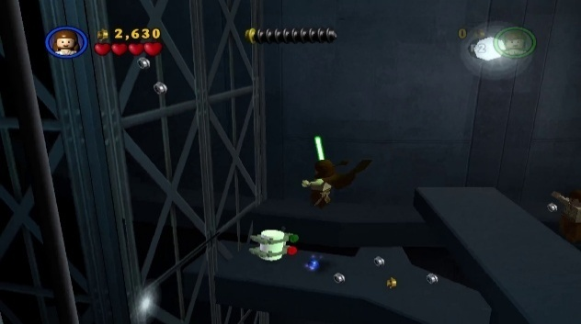Canister 5
  + Address: 0xC2
  + Value: 0x04
* 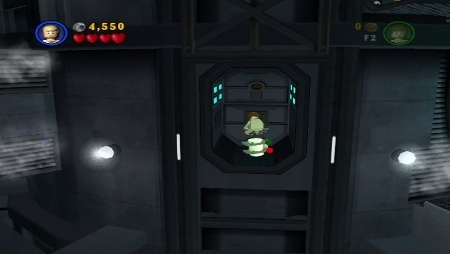Canister 6
  + Address: 0xC2
  + Value: 0x08
* Canister 7
  + 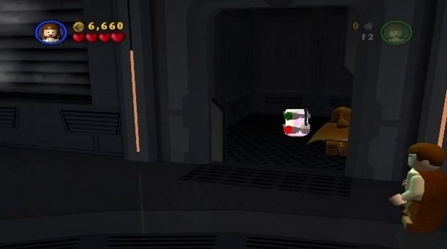Address: 0xC4
  + Value: 0x01
* Canister 8
  + 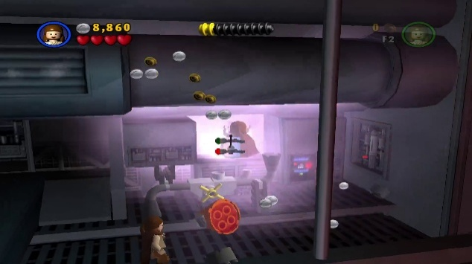Address: 0xC8
  + Value: 0x01
* 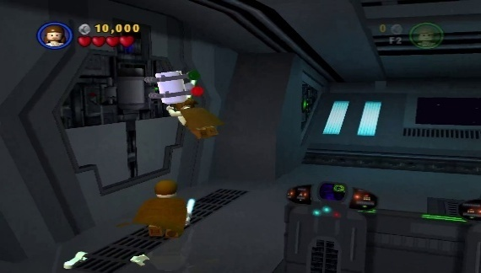Canister 9
  + Address: 0xCA
  + Value: 0x01
* 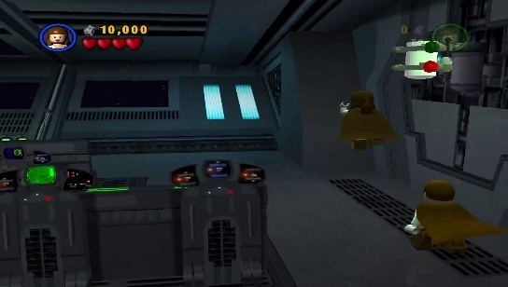Canister 10
  + Address: 0xCA
  + Value: 0x02

#### Chapter 3 General Grievous

* 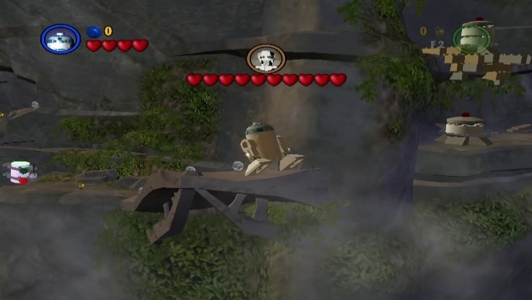Canister 1
  + Address: 0xD4
  + Value: 0x01
* 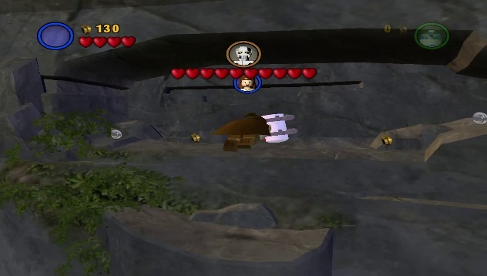Canister 2
  + Address: 0xD4
  + Value: 0x02
* 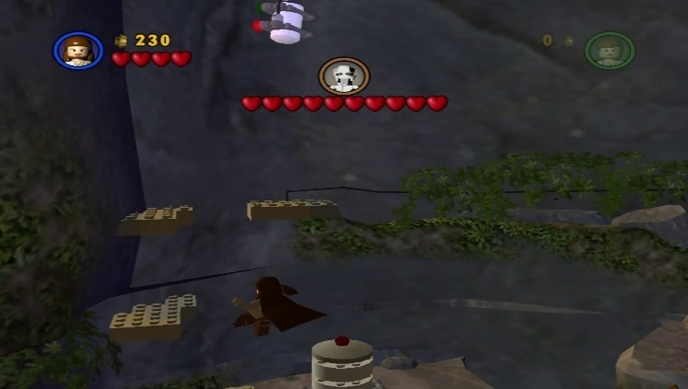Canister 3
  + Address: 0xD4
  + Value: 0x08
* 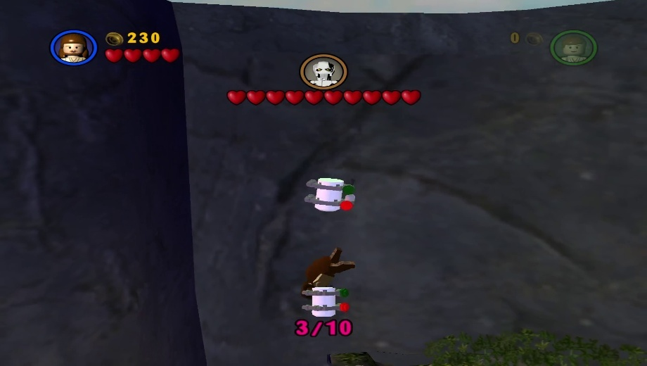Canister 4
  + Address: 0xD4
  + Value: 0x20
* 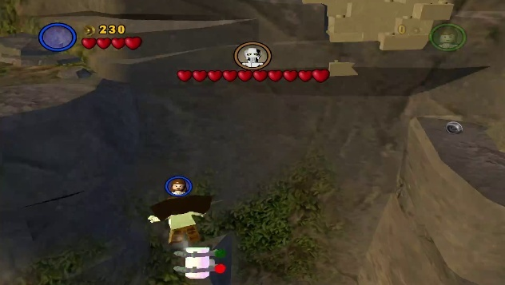Canister 5
  + Address: 0xD5
  + Value: 0x02
* 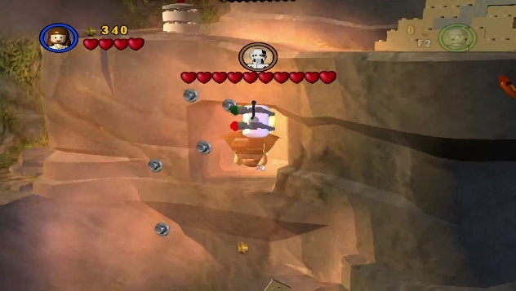Canister 6
  + Address: 0xD4
  + Value: 0x10
* 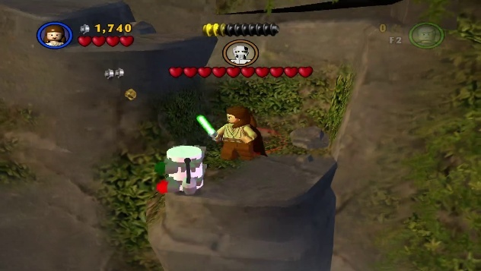Canister 7
  + Address: 0xD5
  + Value: 0x01
* 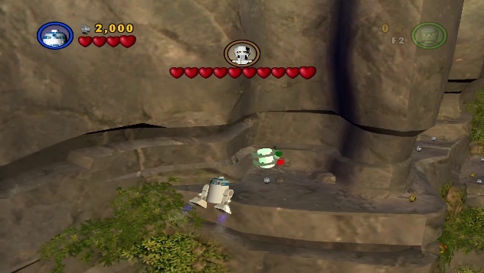Canister 8
  + Address: 0xD4
  + Value: 0x40
* 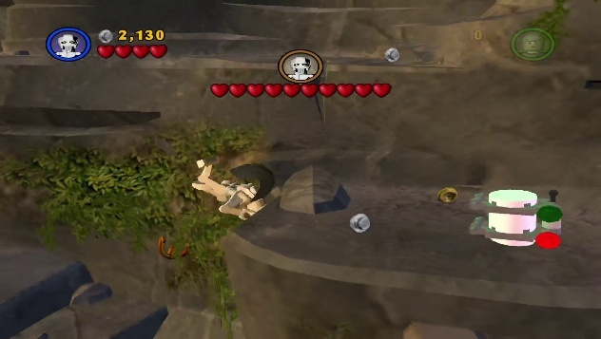Canister 9
  + Address: 0xD4
  + Value: 0x04
* 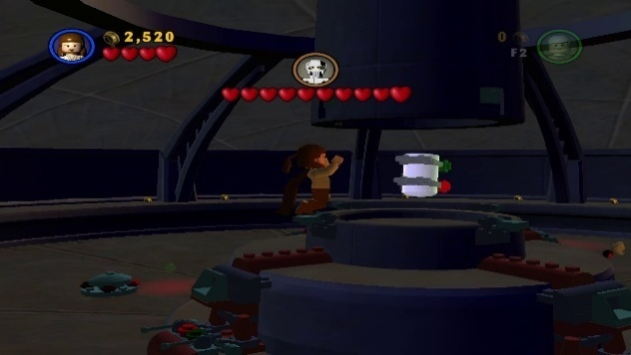Canister 10
  + Address: 0xD4
  + Value: 0x80

#### Chapter 4 Defence Of Kashyyyk

* 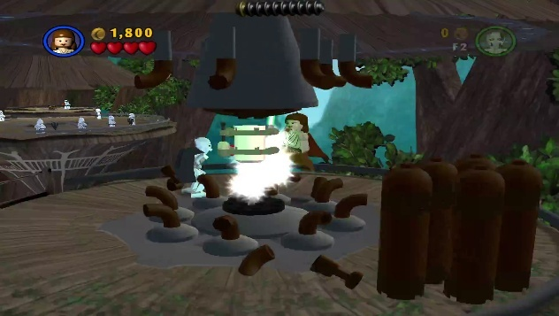Canister 1
  + Address: 0xD8
  + Value: 0x01
* 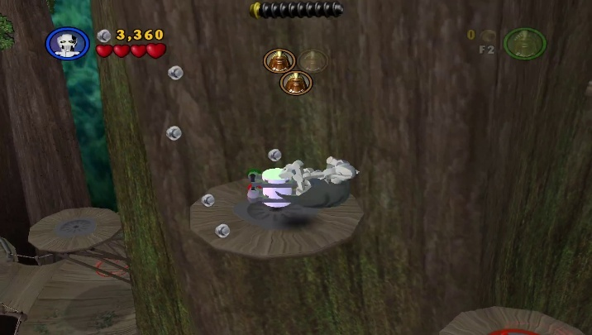Canister 2
  + Address: 0xD8
  + Value: 0x04
* 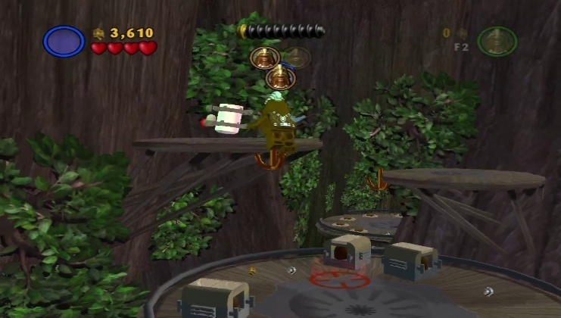Canister 3
  + Address: 0xD8
  + Value: 0x02
* 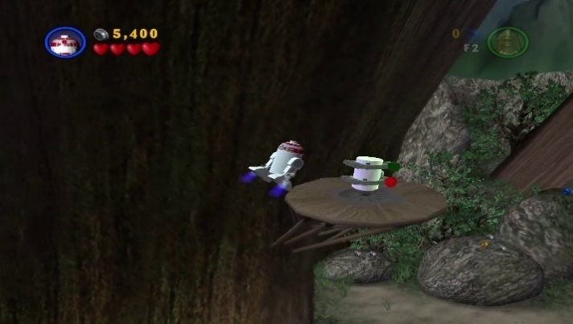Canister 4
  + Address: 0xDA
  + Value: 0x02
* 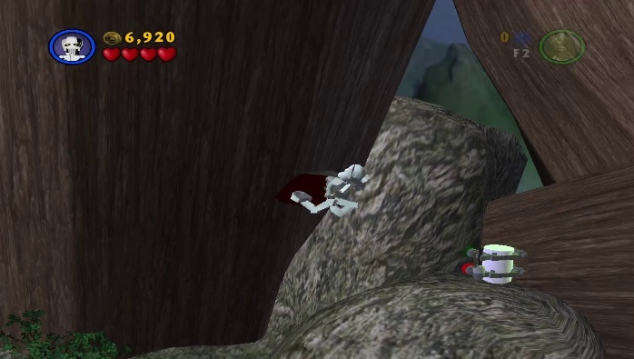Canister 5
  + Address: 0xDA
  + Value: 0x01
* 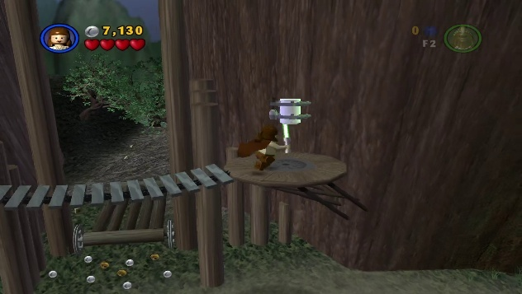Canister 6
  + Address: 0xDA
  + Value: 0x04
* 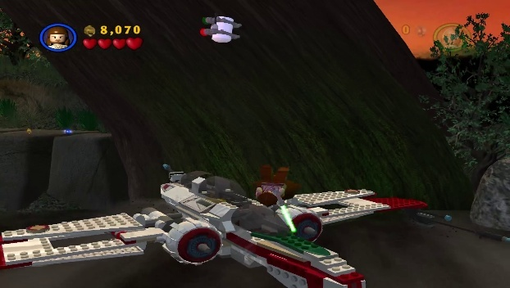Canister 7
  + Address: 0xDC
  + Value: 0x01
* 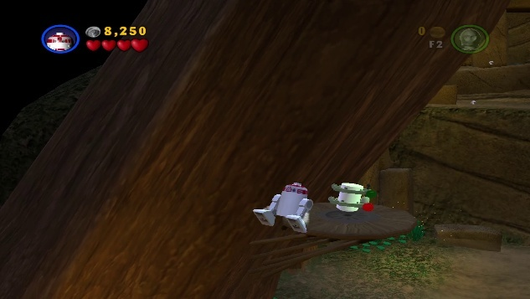Canister 8
  + Address: 0xDE
  + Value: 0x04
* 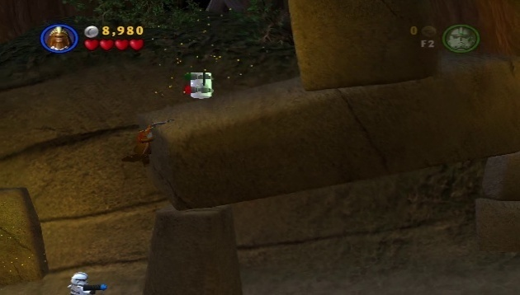Canister 9
  + Address: 0xDE
  + Value: 0x02
* 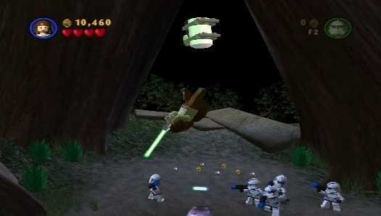Canister 10
  + Address: 0xDE
  + Value: 0x01

#### Chapter 5 Ruin Of The Jedi

* 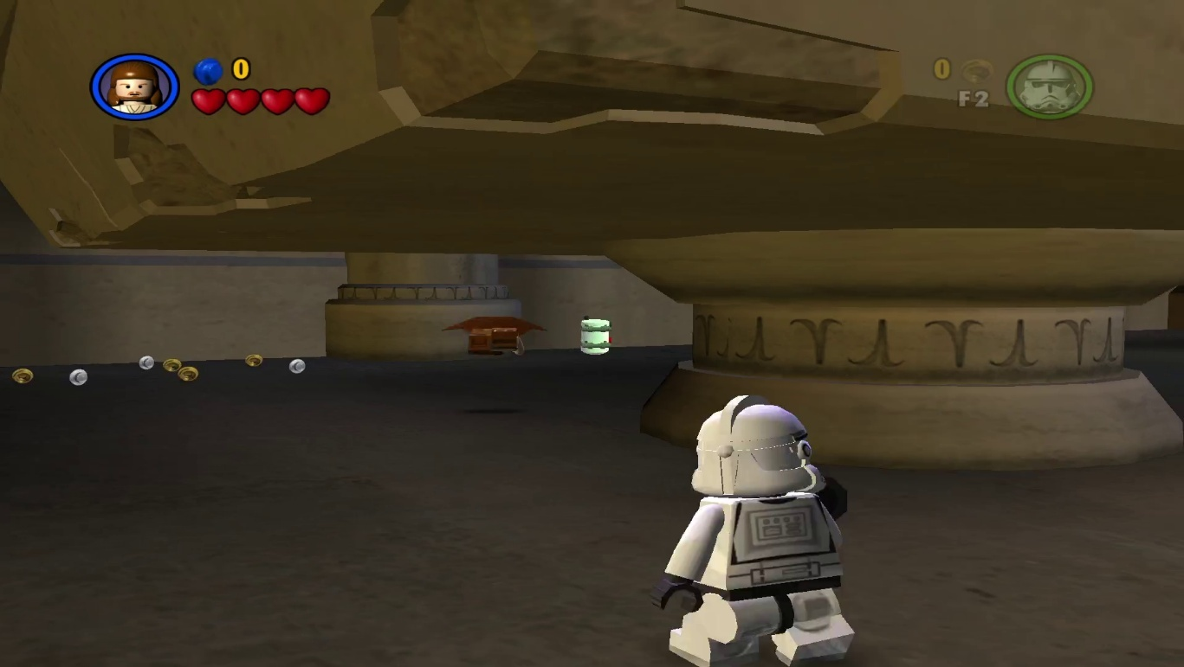Canister 1
  + Address: 0xE6
  + Value: 0x04

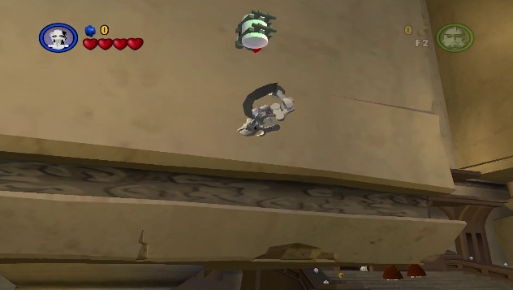

* Canister 2
  + Address: 0xE6
  + Value: 0x02

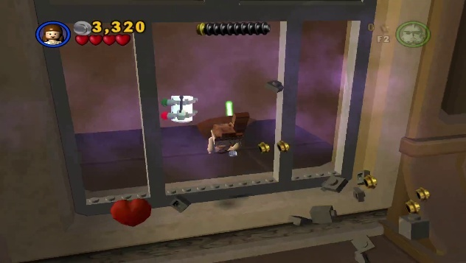

* Canister 3
  + Address: 0xE6
  + Value: 0x01

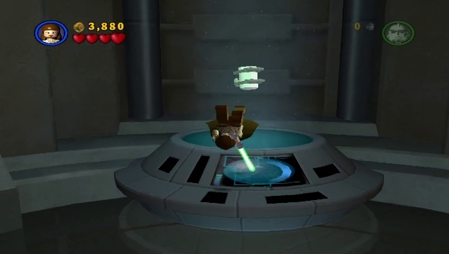

* Canister 4
  + Address: 0xE8
  + Value: 0x02
* 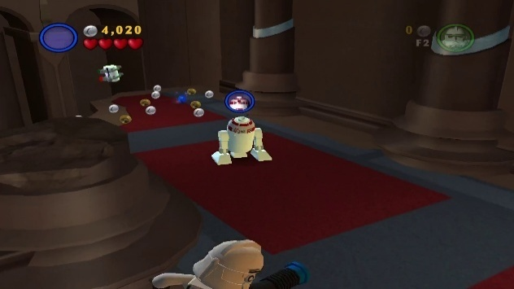Canister 5
  + Address: 0xE8
  + Value: 0x01
* Canister 6
  + Address: 0xE8
  + Value: 0x04

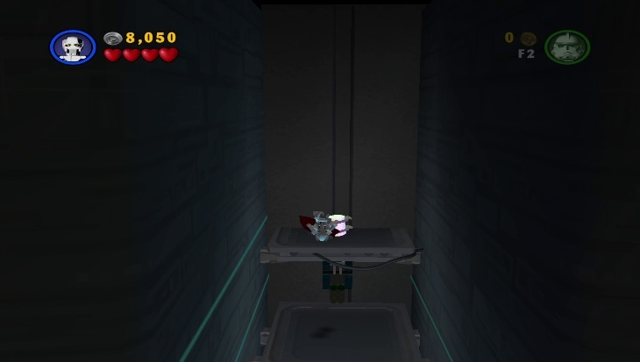

* Canister 7
  + Address: 0xEA
  + Value: 0x02
* 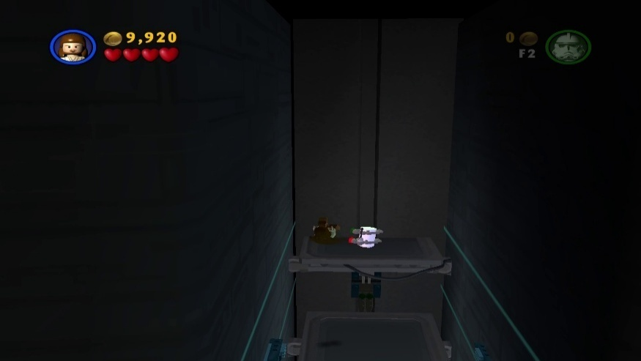Canister 8
  + Address: 0xEA
  + 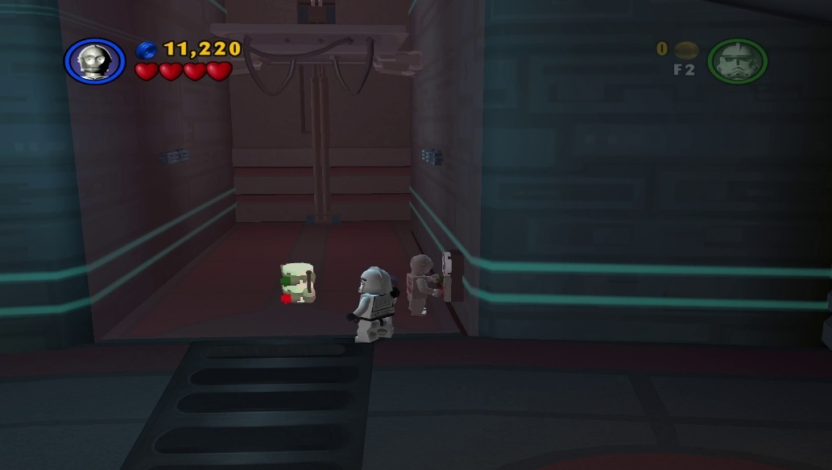Value: 0x01
* Canister 9
  + Address: 0xEA
  + Value: 0x10

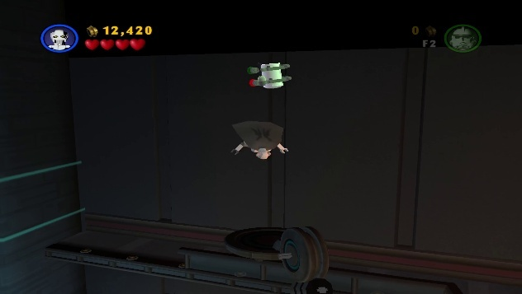

* Canister 10
  + Address: 0xEA
  + Value: 0x04

#### Chapter 6 Darth Vader

* 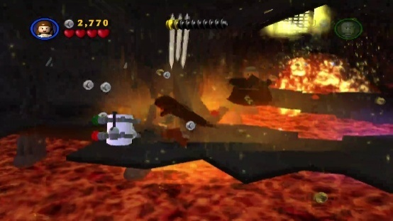Canister 1
  + Address: 0xF0
  + Value: 0x02

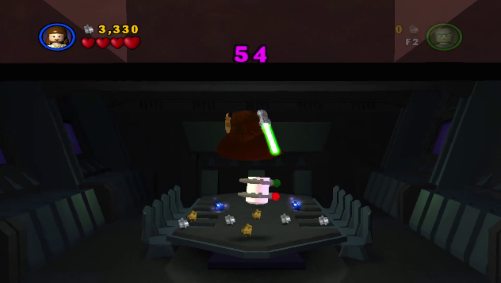

* Canister 2
  + Address: 0xF0
  + Value: 0x01
* 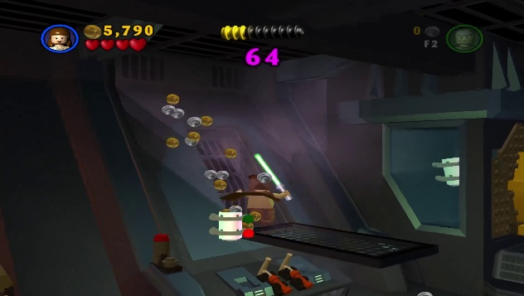Canister 3
  + Address: 0xF0
  + Value: 0x08

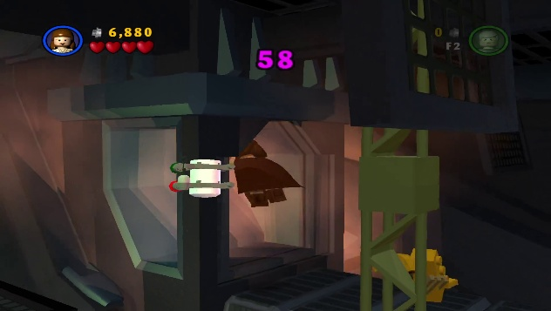

* Canister 4
  + Address: 0xF0
  + Value: 0x10
* 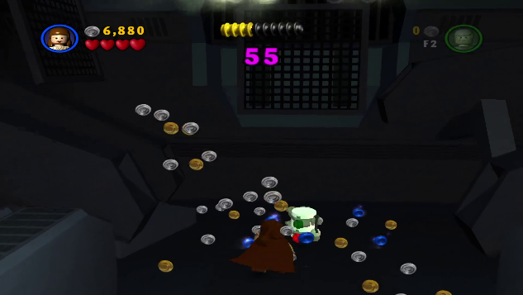Canister 5
  + Address: 0xF0
  + Value: 0x04
* 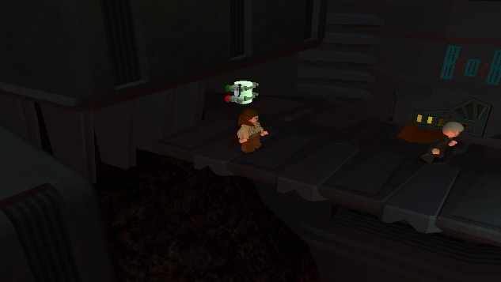Canister 6
  + Address: 0xF2
  + Value: 0x01
* 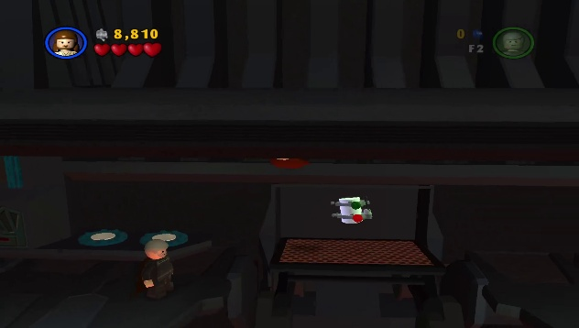Canister 7
  + Address: 0xF2
  + Value: 0x02
* 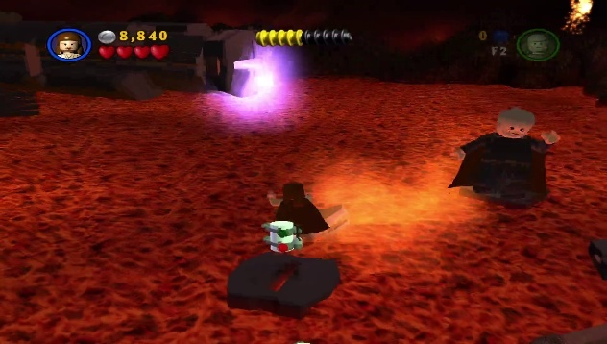Canister 8
  + Address: 0xF4
  + Value: 0x01
* 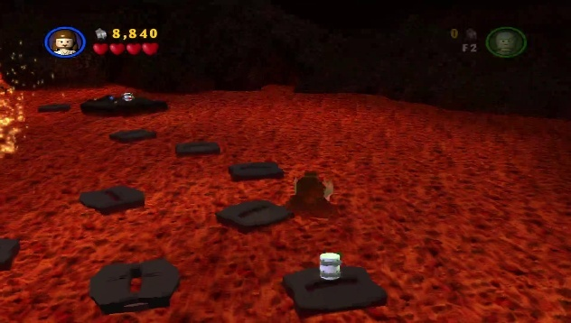Canister 9
  + Address: 0xF4
  + Value: 0x02
* 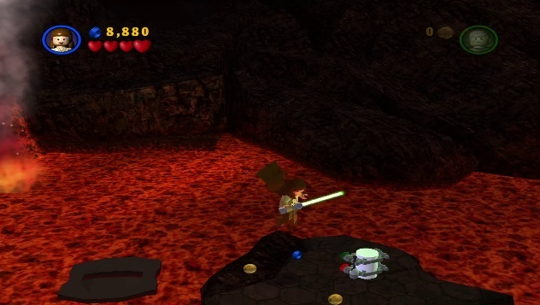Canister 10
  + Address: 0xF4
  + Value: 0x04

## Characters

Unlocked means the character is available to use anywhere except story mode

Bought means the character has been bought in Dexter’s shop

Cheat code used means the character’s cheat code was used and is available to buy in store regardless of progress.

Here is every character and their addresses and values

Qui-Gon Jinn

* Unlocked
  + Address: 0x1D8
  + Value: 0x08

Obi-Wan Kenobi

* Unlocked
  + Address: 0x1D8
  + Value: 0x10

TC-14

* Unlocked
  + Address: 0x1DB
  + Value: 0x40

Jar Jar Binks

* Unlocked
  + Address: 0x1D9
  + Value: 0x02

Queen Amidala

* Unlocked
  + Address: 0x1DB
  + Value: 0x02

Captain Panaka

* Unlocked
  + Address: 0x1DB
  + Value: 0x10

Padmé (Battle)

* Unlocked
  + Address: 0x1DA
  + Value: 0x80

R2-D2

* Unlocked
  + Address: 0x1D9
  + Value: 0x04

Anakin Skywalker (Boy)

* Unlocked
  + Address: 0x1DA
  + Value: 0x10

Obi-Wan Kenobi (Jedi Master)

* Unlocked
  + Address: 0x1D8
  + Value: 0x14

R4-P17

* Unlocked
  + Address: 0x1DD
  + Value: 0x10

Anakin Skywalker (Padawan)

* Unlocked
  + Address: 0x1D9
  + Value: 0x20

Padmé (Geonosis)

* Unlocked
  + Address: 0x1DB
  + Value: 0x01

C-3PO

* Unlocked
  + Address: 0x1DB
  + Value: 0x20

Mace Windu

* Unlocked
  + Address: 0x1DC
  + Value: 0x08

Padmé (Clawed)

* Unlocked
  + Address: 0x1DA
  + Value: 0x40

Yoda

* Unlocked
  + Address: 0x1D9
  + Value: 0x80

Obi-Wan Kenobi (Episode III)

* Unlocked
  + Address: 0x1E4
  + Value: 0x02

Anakin Skywalker (Jedi)

* Unlocked
  + Address: 0x1E3
  + Value: 0x08

Chancellor Palpatine

* Unlocked
  + Address: 0x1E4
  + Value: 0x10

Commander Cody

* Unlocked
  + Address: 0x1E4
  + Value: 0x80

Chewbacca

* Unlocked
  + Address: 0x1E1
  + Value: 0x01

Wookiee

* Unlocked
  + Address: 0x1E4
  + Value: 0x08

Anakin Skywalker (Darth Vader)

* Unlocked
  + Address: 0x1E1
  + Value: 0x40

Stormtrooper

* Unlocked
  + Address: 0x1E3
  + Value: 0x80

Gonk Droid

* Bought
  + Address: 0x1C8
  + Value: 0x01
* Unlocked
  + Address: 0x1E1
  + Value: 0x20

PK Droid

* Bought
  + Address: 0x1C8
  + Value: 0x02
* Unlocked
  + Address: 0x1DD
  + Value: 0x08
* Cheat code used (although this is redundant as PK Droid is available to buy from the start)
  + Address: 0x1F1
  + Value: 0x08

Battle Droid (Security)

* Bought
  + Address: 0x1C8
  + Value: 0x04
* Unlocked
  + Address: 0x1E0
  + Value: 0x01
* Cheat code used
  + Address: 0x1F4
  + Value: 0x01

Battle Droid

* Bought
  + Address: 0x1C8
  + Value: 0x08
* Unlocked
  + Address: 0x1D8
  + Value: 0x04
* Cheat code used
  + Address: 0x1EC
  + Value: 0x04

Battle Droid (Commander)

* Bought
  + Address: 0x1C8
  + Value: 0x10
* Unlocked
  + Address: 0x1DF
  + Value: 0x80
* Cheat code used
  + Address: 0x1F3
  + Value: 0x80

Droideka

* Bought
  + Address: 0x1C8
  + Value: 0x20
* Unlocked
  + Address: 0x1D8
  + Value: 0x02
* Cheat code used
  + Address: 0x1EC
  + Value: 0x02

Royal Guard

* Bought
  + Address: 0x1C8
  + Value: 0x40
* Unlocked
  + Address: 0x1DA
  + Value: 0x04
* Cheat code used
  + Address: 0x1EE
  + Value: 0x04

Padmé

* Bought
  + Address: 0x1C8
  + Value: 0x80
* Unlocked
  + Address: 0x1DA
  + Value: 0x20
* Cheat code used
  + Address: 0x1EE
  + Value: 0x20

Darth Maul

* Bought
  + Address: 0x1C9
  + Value: 0x01
* Unlocked
  + Address: 0x1D9
  + Value: 0x01
* Cheat code used
  + Address: 0x1ED
  + Value: 0x01

Clone

* Bought
  + Address: 0x1C9
  + Value: 0x02
* Unlocked
  + Address: 0x1D8
  + Value: 0x01
* Cheat code used
  + Address: 0x1EC
  + Value: 0x01

Geonosian

* Bought
  + Address: 0x1C9
  + Value: 0x04
* Unlocked
  + Address: 0x1E0
  + Value: 0x08
* Cheat code used
  + Address: 0x1F4
  + Value: 0x08

Battle Droid (Geonosis)

* Bought
  + Address: 0x1C9
  + Value: 0x08
* Unlocked
  + Address: 0x1E0
  + Value: 0x02
* Cheat code used
  + Address: 0x1F4
  + Value: 0x02

Super Battle Droid

* Bought
  + Address: 0x1C9
  + Value: 0x10
* Unlocked
  + Address: 0x1DF
  + Value: 0x40
* Cheat code used
  + Address: 0x1F3
  + Value: 0x40

Jango Fett

* Bought
  + Address: 0x1C9
  + Value: 0x20
* Unlocked
  + Address: 0x1D8
  + Value: 0x80
* Cheat code used
  + Address: 0x1EC
  + Value: 0x80

Boba Fett

* Bought
  + Address: 0x1C9
  + Value: 0x40
* Unlocked
  + Address: 0x1DE
  + Value: 0x20
* Cheat code used
  + Address: 0x1F2
  + Value: 0x20

Luminara

* Bought
  + Address: 0x1C9
  + Value: 0x80
* Unlocked
  + Address: 0x1E5
  + Value: 0x20
* Cheat code used
  + Address: 0x1F9
  + Value: 0x20

Ki-Adi Mundi

* Bought
  + Address: 0x1CA
  + Value: 0x01
* Unlocked
  + Address: 0x1E5
  + Value: 0x80
* Cheat code used
  + Address: 0x1F9
  + Value: 0x80

Kit Fisto

* Bought
  + Address: 0x1CA
  + Value: 0x02
* Unlocked
  + Address: 0x1E6
  + Value: 0x01
* Cheat code used
  + Address: 0x1FA
  + Value: 0x01

Shaak Ti

* Bought
  + Address: 0x1CA
  + Value: 0x04
* Unlocked
  + Address: 0x1E5
  + Value: 0x40
* Cheat code used
  + Address: 0x1F9
  + Value: 0x40

Count Dooku

* Bought
  + Address: 0x1CA
  + Value: 0x08
* Unlocked
  + Address: 0x1D9
  + Value: 0x40
* Cheat code used
  + Address: 0x1ED
  + Value: 0x40

Grievous' Bodyguard

* Bought
  + Address: 0x1CA
  + Value: 0x10
* Unlocked
  + Address: 0x1E6
  + Value: 0x02
* Cheat code used
  + Address: 0x1FA
  + Value: 0x02

General Grievous

* Bought
* Address: 0x1CA
* Value: 0x20
* Unlocked
  + Address: 0x1E1
  + Value: 0x04
* Cheat code used
  + Address: 0x1F5
  + Value: 0x04

Clone (Episode III)

* Bought
  + Address: 0x1CA
  + Value: 0x40
* Unlocked
  + Address: 0x1E4
  + Value: 0x20
* Cheat code used
  + Address: 0x1F8
  + Value: 0x20

Clone (Episode III, Pilot)

* Bought
  + Address: 0x1CA
  + Value: 0x80
* Unlocked
  + Address: 0x1E4
  + Value: 0x40
* Cheat code used
  + Address: 0x1F8
  + Value: 0x40

Clone (Episode III, Swamp)

* Bought
  + Address: 0x1CB
  + Value: 0x01
* Unlocked
  + Address: 0x1E5
  + Value: 0x01
* Cheat code used
  + Address: 0x1F9
  + Value: 0x01

Clone (Episode III, Walker)

* Bought
  + Address: 0x1CB
  + Value: 0x02
* Unlocked
  + Address: 0x1E5
  + Value: 0x02
* Cheat code used
  + Address: 0x1F9
  + Value: 0x02

Mace Windu (Episode III)

* Bought
  + Address: 0x1CB
  + Value: 0x04
* Unlocked
  + Address: 0x1E2
  + Value: 0x08
* Cheat code used
  + Address: 0x1F6
  + Value: 0x08

Disguised Clone

* Bought
  + Address: 0x1CB
  + Value: 0x08
* Unlocked
  + Address: 0x1E4
  + Value: 0x04
* Cheat code used
  + Address: 0x1F8
  + Value: 0x04

Darth Sidious

* Bought
  + Address: 0x1CB
  + Value: 0x10
* Unlocked
  + Address: 0x1D8
  + Value: 0x40
* Cheat code used
  + Address: 0x1EC
  + Value: 0x40

Rebel Trooper

* Bought
  + Address: 0x1CB
  + Value: 0x20
* Unlocked
  + Address: 0x1F0
  + Value: 0x02
* Cheat code used
  + Address: 0x1F0
  + Value: 0x02

Princess Leia

* Bought
  + Address: 0x1CB
  + Value: 0x40
* Unlocked
  + Address: 0x1E7
  + Value: 0x10
* Cheat code used
  + Address: 0x1FB
  + Value: 0x10

## Extras

Bought extras are stored across a 2-byte memory address from 0x1D0 to 0x1D1. This reflects the Extras bought in Dexter’s shop.

Here is each memory address and the extras it contains, along with the associated value:

* Address 0x1D0
  + Extra: Invincibility
    - Value: 0x01
  + Extra: Silhouettes
    - Value: 0x02
  + Extra: Purple
    - Value: 0x04
  + Extra: Moustaches
    - Value: 0x08
  + Extra: Minikit Detector
    - Value: 0x10
  + Extra: Tea cups
    - Value: 0x20
  + Extra: Brushes
    - Value: 0x40
  + Extra: Big Blasters
    - Value: 0x80
* Address 0x1D1
  + Extra: Classic Blasters
    - Value: 0x01
  + Extra: Classic Blasters
    - Value: 0x02

Extras are stored across a 2-byte memory address from 0x200 to 0x201. This reflects Extras unlocked and available to use.

Here is each memory address and the extras it contains, along with the associated value:

* Address 0x200
  + Extra: Invincibility
    - Value: 0x01
  + Extra: Silhouettes
    - Value: 0x02
  + Extra: Purple
    - Value: 0x04
  + Extra: Moustaches
    - Value: 0x08
  + Extra: Minikit Detector
    - Value: 0x10
  + Extra: Tea cups
    - Value: 0x20
  + Extra: Brushes
    - Value: 0x40
  + Extra: Big Blasters
    - Value: 0x80
* Address 0x201
  + Extra: Classic Blasters
    - Value: 0x01
  + Extra: Classic Blasters
    - Value: 0x02